

**Cipher Protocol Shadow Nexus - Cyberpunk Action Stealth Game Project Management Execution**

**FIT5057 Project Management**

**Assignment Two – Team Assignment Individual Submission**

MONTH 2024 September 30

Student ID and Full Name:33429472 Ziqi Pei

Team number:603

Applied class:Applied Friday 5-7pm

# Contents

DELIVERABLE 1: Project Integration Management

Task 1 Project Charter.................................................................................................................................3

DELIVERABLE 2: Project Scope management ..........................................................................10

Task 2.1 Requirements Traceability Matrix (RTM)..........................................................10

Task 2.2 Project Scope Statement .....................................................................................13

DELIVERABLE 3: Project Work Breakdown structure and Project Schedule Management......24

Task 3.1 Work Breakdown Structure (WBS) - Individual Written Submission ...............24

Task 3.2 Short reflection on developing the WBS through team collaboration - Individual Written Submission............................................................................................................31

Task 3.3 Gantt Chart - Individual Written Submission ....................................................32

Task 3.4 In-class Demonstration .......................................................................................37

DELIVERABLE 4: Project Cost Management ............................................................................38

Task 4.1 One-page Cost Model.........................................................................................38

Task 4.2 Cost Baseline......................................................................................................46

Task 4.3 Summary of Assumptions..................................................................................50

DELIVERABLE 5: Project Risk Management ...........................................................................60

Task 5.1 Risk Register......................................................................................................60

Task 5.2 Probability & Impact Rationale..........................................................................64

Task 5.3 The Matrix & Analysis.......................................................................................70

DELIVERABLE 6: Project Quality Management ......................................................................74

Task 6.1 Quality Standards/Requirements.......................................................................74

Task 6.2 Metrics and Measurement.................................................................................76

DELIVERABLE 8: Project Stakeholder and Communication Management .............................81

Task 7.1 Building Your Stakeholder Register.................................................................81

Task 7.2 Engagement Strategy.........................................................................................86

References....................................................................................................................................91

# DELIVERABLE 1: Project Integration Management

## Task 1 Project Charter

**Project Title**:Cipher Protocol:Shadow Nexus

**Project Start Date:**February 1 st,2025 **Projected Finish Date:** January 31st,2026

**Budget Information:** $1,200,000

**Project Manager:** Ziqi Pei

**Phone**:0458133985

**E-mail:**zpei0003@student.monash.edu

**Project Objectives:**

Cipher Protocol is an ambitious cyberpunk stealth-action game set in a dystopian metropolis ruled by powerful corporations. Players take on the role of a skilled rogue hacker, using their intelligence and technical expertise to infiltrate fortified facilities, manipulate advanced surveillance systems, and expose the city’s dark secrets.

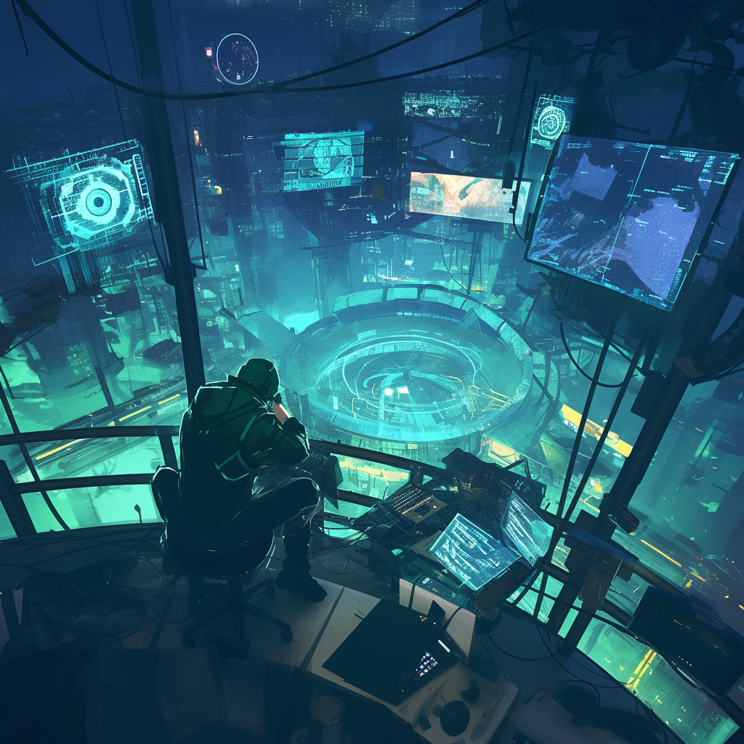

**Standout Features:**

**(1)Dynamic Level Design:** Offers vertical exploration, scaling skyscrapers, navigating tunnels, and hacking drones for diverse mission approaches.

**(2)Immersive Moral Choice System:** Decisions impact the city's power structure, influencing the game world in real-time, providing a personalized and replayable experience.

**Technological Edge:**

Each decision players make has far-reaching consequences on the city's power structure. Whether they choose to reinforce corporate control, support rebellious factions, or push society towards chaos, these choices will shape the evolving game world, providing a deeply personal and replayable experience.

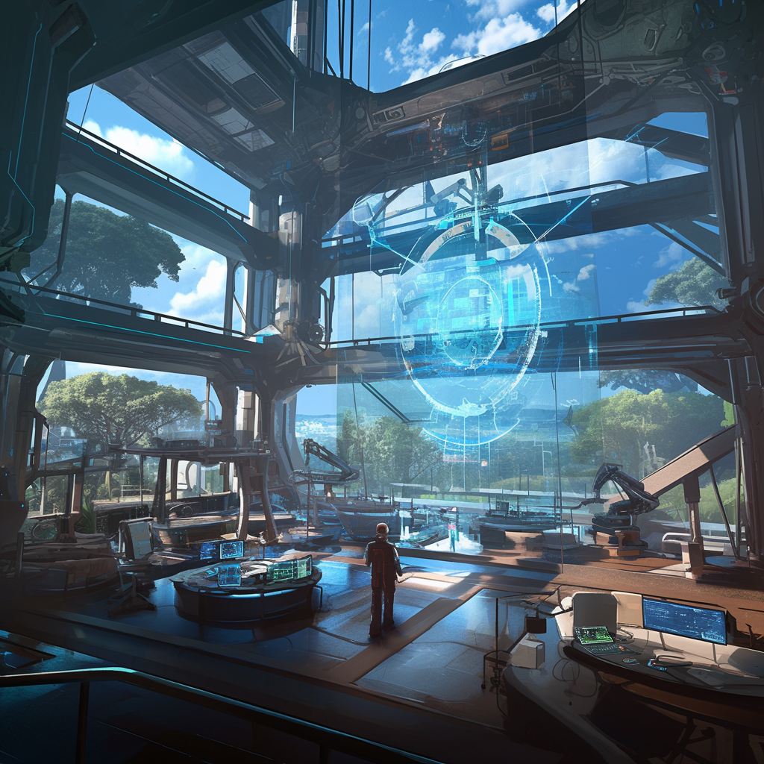

To bring this vision to life, Cipher Protocol employs cutting-edge technology. Academic studies highlight the growing demand for immersive, open-world games that offer players autonomy (Adams & Rollings, 2014), and Cipher Protocol aims to meet this demand with features such as dynamic levels and moral choice systems. Each decision players make influences the in-game world, aligning with current research into narrative-driven gameplay (Tanenbaum, 2015).



**Alignment of the project with business strategy:**

Cipher Protocol: Shadow Nexus aligns with NexaForge Studios' strategic goals by:

1.Entering new markets: Leveraging the popularity of cyberpunk themes to attract new players, as uggested by trends in game design literature (Schwaber, 2013).

2.Driving innovation: Utilizing cutting-edge game technologies to set new industry standards, an essential factor in competitive advantage (Boehm, 1988).

3.Establishing market leadership: Delivering a unique experience that positions the studio as a leader in narrative-driven games (Beck et al., 2001).

4.Enhancing profitability: Focusing on replayability and downloadable content (DLC) to create sustained revenue streams (Petrillo et al., 2009).

5.Building brand recognition: Aiming for critical acclaim to boost the studio's reputation and credibility

**Main Project Success Criteria:**

### The core strengths of Cipher Protocol can be highlighted in four key areas.

### **Engagement:** First, the game creates a captivating and unique cyberpunk world, drawing players in with its meticulously crafted storyline.

### **Innovation:** it innovatively blends hacker elements with traditional stealth-action gameplay, offering players a fresh and unparalleled gaming experience.

### **Replayability:** its highly replayable dynamic level design ensures long-lasting appeal, allowing players to encounter new challenges and surprises with every playthrough.

### IMG_256**Adaptive AI:**Finally, the game's deep interactivity—where player choices significantly impact the game world—greatly enhances immersion and engagement

### IMG_256.

### **Performance Goals:**

### **1. Gameplay Experience**

### **(1)Objective:** Deliver a seamless and immersive gameplay experience.

### **(2)Target:** Achieve a 70% improvement in gameplay fluidity by enhancing game engine efficiency, ensuring a minimum of 60 FPS across all platforms by November 30th, 2025.

### **(3)Impact:** Enhance player satisfaction, leading to a 20% increase in positive feedback related to gameplay experience.

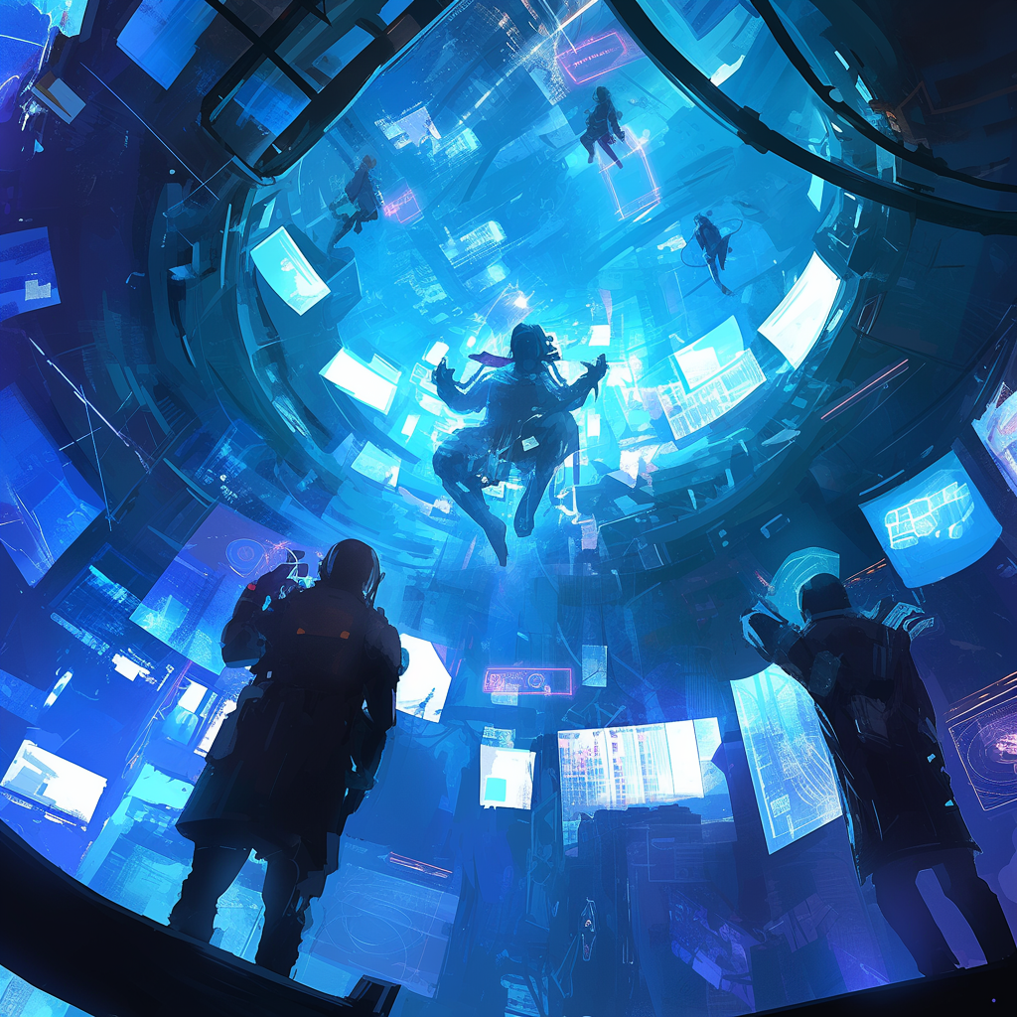

### **2. Development Efficiency**

### **(1)Objective:** Optimize game development through AI integration.

### **(2)Target:** Decrease development time by 60% by integrating adaptive AI and procedural level generation by October 31st, 2025.

### **(3)Impact**: Enable faster content updates and quicker releases to keep players engaged.



### **3. Player Retention**

### **(1)Objective:** Boost player retention through enhanced replayability.

### **(2)Target:** Increase player retention by 50% within six months post-launch, with at least 30% of players completing multiple story arcs by July 31st, 2026.

### **(3)Impact:** Reduce player churn by 25% in the first month and foster a loyal community.

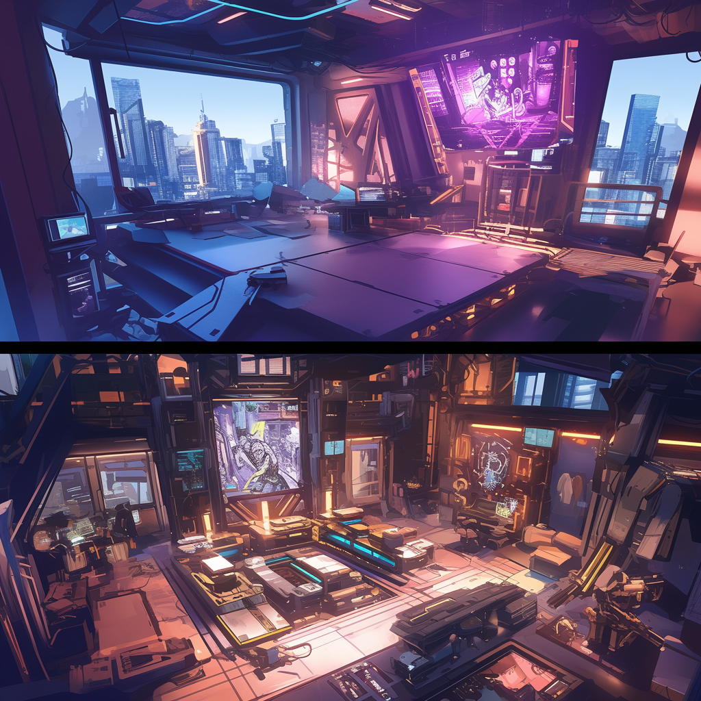

### **4. Performance Optimization**

### **(1)Objective:** Reduce lag and load times by at least 50% compared to initial prototypes by September 30th, 2025.

### **(2)Target:** Ensure the game runs at a minimum of 60 FPS across all targeted platforms (PC, PS5, Xbox Series X).

### **(3)Impact:** Achieve frame rates above 60 FPS for 95% of gameplay, enhancing player immersion and satisfaction.



### **5. Critical Acclaim**

### **(1)Objective:** Secure at least three nominations from major gaming awards and sell 1 million units within the first year.

### **(2)Target:** Achieve a Metacritic score of 85+ within the first year post-launch.

### **(3)Impact:** Establish Cipher Protocol: Shadow Nexus as a top-tier game, resulting in a 20% increase in brand recognition.

**Project development approach:**

**Target Market Cipher Protocol's target:**

1. **Audience:**

Cipher Protocol targets a core audience of hardcore gamers on console and PC platforms, particularly those aged 18-35 who appreciate deep narratives and complex gameplay mechanics. The resurgence of cyberpunk themes in popular culture has led to increasing demand for related games, and Cipher Protocol aims to capitalize on this trend.

**(2)Market and Marketing:**

Our multi-channel marketing strategy will focus on social media platforms such as Facebook, Twitter, and Instagram to engage directly with potential players. This includes interactive content, developer diaries, and teaser trailers designed to build anticipation pre-launch. Additionally, Cipher Protocol will be showcased at major gaming expos such as E3 and Gamescom, leveraging real-time demonstrations to highlight the game’s unique features. Post-launch, we will maintain player engagement through regular content updates, community events, and feedback-driven improvements.

**(3)Target Market:**

The game appeals to players who enjoy immersive single-player experiences, especially fans of the cyberpunk genre and stealth-based gameplay. Our target market is tech-savvy, appreciates deep storytelling, and seeks complex moral decision-making in games. The demand for narrative-driven games within this genre is rapidly growing, and Cipher Protocol aims to meet this demand with its fresh and innovative approach.

**(4)Market Demand:**

With the rising popularity of high-quality, narrative-driven games, Cipher Protocol is positioned to attract millions of players worldwide. Initial projections indicate strong interest and high pre-order numbers, largely driven by early marketing efforts and community feedback. We anticipate the game to fill a key niche within NexaForge Studios' portfolio, offering a unique blend of cyberpunk aesthetics and innovative gameplay.

**Hybrid Development Approach:**

Cipher Protocol will use a hybrid development approach that integrates predictive, waterfall, and agile methodologies. This is in line with industry practices for managing large, complex game projects (Pressman, 2014).

**(1)Predictive Approach:**

For well-defined technical components, such as the AI behavior tree system and dynamic level generation, we will use a predictive approach. This allows us to set fixed budgets, deadlines, and performance standards based on previously successful implementations in similar games (Schwaber, 2013).

**(2)Waterfall Approach:**

Cinematic sequences, character models, and narrative scripts will follow a Waterfall approach, where development proceeds sequentially. This ensures that each stage of production aligns with the creative vision, allowing for a controlled and linear development process (Royce, 1970).

**(3)Agile Methodology:**

For gameplay mechanics and level design, we will adopt Agile principles. Agile allows for adaptive planning and continuous feature delivery, responding to player feedback from playtesting to refine the game in iterative cycles. Regular sprints will ensure that user experience remains a core focus throughout the development process(Beck et al., 2001).

**(4)Testing**

Given the significant cybersecurity risks associated with game development, particularly with regards to game data integrity and player privacy, the project will prioritize rigorous planning, strict adherence to budget, and clear timelines Continuous Integration (CI) and automated testing practices will be employed to ensure game stability and cross-platform performance.

**Studio Strategy:**

1. **Short-term**

Focus all resources on the high-quality development and successful release of the game. We will maintain close communication with publishers and platform partners to ensure a smooth launch.

1. **Medium-term:**

Extend the game's lifecycle through DLCs and regular updates, which are critical to maintaining engagement post-launch (Bethke, 2003). We plan to release at least two major story DLCs to expand the game world and enhance gameplay.

1. **Long-term:**

Our goal is to build Cipher Protocol into a lasting game IP. Establish Cipher Protocol as a lasting IP, with sequels and expansions into other media formats like comics or animated series (Tanenbaum & Bizzocchi, 2009).Establishing Cipher Protocol as a benchmark in the cyberpunk genre will ensure continued market presence and growth.

**Time Estimate:**

The project is expected to take 18 months to complete, with a scheduled release in the first quarter of 2026. Major milestones include:

**(1)Prototype Development (3 months):** Proof of concept and initial gameplay design.

**(2)Core Gameplay Completion (8 months):** Finalizing key gameplay mechanics, AI integration, and dynamic level design.

**(3)Content Production and Polish (7 months):** Completing game content, fixing bugs, and optimizing the game for release.

**Financing and Finance:**

**Budget:** AUD 1.2 million covering development, licensing, and marketing.

**Revenue Projections:** Expect to sell 1 million copies within the first year, with additional revenue from DLCs.

**Roles and Responsibilities**

The development of Cipher Protocol is led by an experienced team. Our Creative Director has over 10 years of experience in AAA game development and has been involved in the production of several well-known IPs. The Technical Director has a strong professional background in open world game development and can ensure that our technical implementation matches the creative vision(Clarke & O'Connor, 2012). . The Art Director is well-known in the industry for his unique cyberpunk style design, which will bring visual shocks to the game. In addition, we have also hired senior game planners, AI programmers and sound designers to form an all-round elite team. This team is not only technically proficient, but more importantly, they share a common love for the cyberpunk theme, which will ensure that Cipher Protocol will become a passionate and creative work.

The management team consists of industry veterans with extensive experience in game development, marketing, and business management. The team’s expertise ensures that Cipher Protocol meets the high standards expected by the gaming community and achieves commercial success. Key members include chief developers, creative directors, marketing strategists, and financial advisors, all of whom bring valuable insights and skills to the project.

|  |  |  |  |
| --- | --- | --- | --- |
| **Role in the project** | **Name** | **Position in the organisation/contract** | **Contact Information** |
| Project Manager | Ziqi Pei | Overall project execution and stakeholder management | zpei0003@student.monash.edu |
| Creative Director | Xiaoyao Li | Vision, plot design, and gameplay design leadership | xli0001@student.monash.edu |
| Technical Director | James Chen | Game engine development and technical support | jchen0002@student.monash.edu |
| Art Director | Emily Wong | Visual style, character design, and environment design | ewong0003@student.monash.edu |
| Audio Director | Alex Smith | Game music, sound effects, and voice acting direction | asmith0004@student.monash.edu |
| Producer | Xiaofan Liu | Responsible for resource allocation and progress control | xliu0005@student.monash.edu |
| QA Manager | YuCheng Shi | Game testing and quality control | yshi0006@student.monash.edu |
| Marketing Manager | Sarah Johnson | Promotional strategies and marketing campaigns | sjohnson0007@student.monash.edu |
| Chief Financial Officer | Michael Zhang | Budget oversight and financial planning | mzhang0008@student.monash.edu |
| Community Manager | Lisa Brown | Player engagement and community building | lbrown0009@student.monash.edu |

**Sign-off:**By This Project Charter serves as a comprehensive guide, demonstrating the alignment between our project's objectives and the client's business strategy. It outlines clear, measurable success criteria, addresses potential risks with mitigation strategies, and includes key stakeholders to ensure effective communication and project execution.

|  |  |  |  |
| --- | --- | --- | --- |
| **Name** | **Confirm** | **Date** | **Signature** |
| **Ziqi Pei** | Confirm | February 1st, 2025 | Ziqi Pei |
| **Xiaoyao Li** | Confirm | February 1st, 2025 | Xiaoyao Li |
| **James Chen** | Confirm | February 1st, 2025 | James Chen |
| **Emily Wong** | Confirm | February 1st, 2025 | Emily Wong |
| **Alex Smith** | Confirm | February 1st, 2025 | Alex Smith |
| **Xiaofan Liu** | Confirm | February 1st, 2025 | Xiaofan Liu |
| **YuCheng Shi** | Confirm | February 1st, 2025 | YuCheng Shi |
| **Sarah Johnson** | Confirm | February 1st, 2025 | Sarah Johnso |
| **Michael Zhang** | Confirm | February 1st, 2025 | Michael Zhang |
| **Lisa Brow** | Confirm | February 1st, 2025 | Lisa Brown |

**Comments:** We have reviewed the terms of the stakeholder Roles and Responsibilities and agree to abide by the guidelines. We understand that these roles and responsibilities will be reviewed quarterly or as necessary. We commit to actively participating in discussions regarding any changes or updates. Any amendments will be collectively discussed and approved by the entire team.

# DELIVERABLE 2: Project Scope Management

## Task 2.1 Requirements Traceability Matrix (RTM)

|  |  |  |  |  |  |
| --- | --- | --- | --- | --- | --- |
| **REQUIREMENTS TRACEABILITY MATRIX** | | | | | |
| **Project Name:** | **Cipher Protocol: Shadow Nexus** | | | | |
| **Project Manager Name:** | **Ziqi Pei** | | | | |
| **Project Description:** | **Product Development Background**  Cipher Protocol is designed to enhance player retention and satisfaction by offering unique level designs and mechanics that keep players engaged over extended periods. With the rising demand for cyberpunk-themed games, especially after the success of titles like Cyberpunk 2077, Cipher Protocol was developed to meet the need for innovation in both visual and gameplay experiences (CD Projekt Red, 2020).  Stealth action games, in particular, require deeper connections between game mechanics and narrative immersion. Cipher Protocol addresses this demand by blending cyberpunk aesthetics with intricate stealth mechanics, dynamic level design, and multi-layered narrative choices. The goal is to provide players with a truly unique experience that sets new standards for the genre (Adams & Rollings, 2014).  Drawing inspiration from games like Deus Ex: Human Revolution, known for its complex level design and player-driven narrative, Cipher Protocol elevates the cyberpunk theme by introducing realistic hacking mechanics and futuristic technology (Square Enix, 2011). Extensive research into cybersecurity and city architecture informed the development process, ensuring that the game world feels authentic and compelling (Schneier, 2015; Goodfellow et al., 2016).  **Core Products and Features**  **(1)Dynamic Level Design:** Supports vertical exploration and offers multiple stealth routes, allowing players to approach missions in various ways.  **(2)Complex Moral Choice System:** Player decisions directly affect the storyline and the game's world state, leading to diverse gameplay experiences (Ryan, 2001).  **(3)Hacker Skill Tree and Upgradeable Equipment:** Players can unlock advanced skills and customize their equipment, providing depth and variety to the gameplay. (Bissell, 2018)  **(4Multiple Endings:** A branching narrative structure allows for different outcomes based on player choices, significantly increasing replayability (Gee, 2003).  **Key Features**  **(1)Open Level Design:** Each mission supports various completion strategies, including frontal assaults, covert stealth, or remote hacking, improving replayability and player choice (Schell, 2008).  **(2)Innovative Hacker Ability Tree:** Players unlock a range of advanced hacker skills as they progress, adding new possibilities to the gameplay experience.  **(3)Branching Narrative Structure:** Player decisions directly shape the plot and the state of the game world, fostering deep interactivity and immersion in the cyberpunk dystopia (Juul, 2005).  **(4)Immersive Cyberpunk World:** Detailed environments and interactive elements create an atmospheric experience of a dystopian future (Bishop, 2020). | | | | |
| ***ID*** | ***Requirements (Functional or Non-Functional)*** | ***Assumption(s) and/or Customer Need(s)*** | ***Category*** | ***Source*** | **Status** |
| R01 | Player should be able to choose between stealth and combat options. | Players prefer multiple approaches to complete missions. | Functional | Game Design Document | In Progress |
| R02 | AI NPC behavior should adapt to player choices dynamically. | Players want a challenging and responsive AI system. | Functional | Stakeholder Meeting | Pending |
| R03 | Game should run at 60 FPS across all platforms. | Ensuring a smooth experience on mainstream devices. | Non-Functional | Non-Functional | In Progress |
| R04 | Levels should change dynamically based on player actions. | Enhances immersion and replayability. | Functional | Game Design Document | In Progress |
| R05 | Data encryption for player information and save files. | Ensuring player data privacy and security. | Non-Functional | Security Requirements | Not Started |
| R06 | Integration of in-game audio with dynamic level changes. | Synchronizing audio cues with game actions for a more immersive experience. | Functional | Audio Design Document | Pending |
| R07 | Ensure cross-platform compatibility with minimal loading times. | Players expect consistent gameplay across platforms. | Non-Functional | Technical Specification | In Progress |
| R08 | Provide regular downloadable content (DLC) updates. | Sustaining player engagement and long-term retention. | Functional | Marketing Plan | Not Started |
| R09 | Implement a complex moral choice system that impacts story progression | Players want their choices to have a significant impact on the game world | Functional Requirement | Player Feedback | Player Feedback |
| R10 | Develop a hacking skill tree and upgradeable equipment system | Provide deep character customization and growth experience | Functional Requirement | Game Design Document | Game Design Document |
| R11 | The game should support multiplayer mode with cooperative or competitive play | Expand game replayability and social interaction | Functional Requirement | Market Demand Analysis | Market Demand Analysis |
| R12 | Ensure server stability under high load conditions | Prevent server crashes and provide a seamless multiplayer experience | Non-Functional Requirement | Technical Specification | Technical Specification |
| R13 | Implement dynamic weather and day/night cycle system | Enhance realism and visual appeal | Functional Requirement | Art Design Document | Art Design Document |
| R14 | Provide a detailed tutorial and help system | Ensure players can quickly learn the game | Service Requirement | Customer Support Department | Customer Support Department |
| R15 | Ensure the game complies with regional laws and ethical standards | Avoid legal risks and ensure global release | Non-Functional Requirement | Legal Consultant | Legal Consultant |

## **Note:** These references are adapted from design principles discussed in sources such as Adams and Rollings (2014) and Schneier (2015) for cybersecurity considerations.

## Task 2.2 Project Scope Statement

|  |  |
| --- | --- |
| **PROJECT** | **DATE** |
| **Cyberpunk Action Stealth Game Project Management Execution** | **Project Start Date**: February 1st, 2025 **Projected Finish Date**: January 31st, 2026 |
| **PROJECT BACKGROUND, OBJECTIVES and OUTCOMES** | |
| **1.Project Background** NexaForge Studios aims to redefine the cyberpunk genre with Cipher Protocol: Shadow Nexus, a stealth-action game designed to captivate players seeking immersive narratives and challenging gameplay. Set in a dystopian metropolis, players will assume the role of a skilled hacker, navigating a world of corporate intrigue and moral dilemmas. By combining dynamic level design, adaptive AI, and a robust moral choice system, Cipher Protocol offers a uniquely engaging experience that aligns perfectly with NexaForge's commitment to innovation and storytelling (Ryan, 2001).  The project directly addresses a gap in the market for cyberpunk games that offer deep, meaningful choices and highly replayable content. Leveraging the popularity of cyberpunk aesthetics and the growing demand for more complex gameplay mechanics, Cipher Protocol is poised to become a standout title in the gaming industry (CD Projekt Red, 2020).  **2.Project Objectives**  **(1)Create a Memorable Narrative**: Develop a compelling and morally ambiguous storyline that allows players to shape the outcome of the game through their choices (Juul, 2005).  **(2)Deliver Exceptional Gameplay:** Implement a robust and responsive gameplay system, featuring a balance of stealth and combat mechanics, and a dynamic level design that adapts to player choices.  **(3)Achieve Critical Acclaim:** Secure a Metacritic score of 88+ within the first year of release and garner nominations for at least five major gaming awards.  **(4)Build a Loyal Community:** Foster a strong player community through regular updates, community events, and ongoing support (Bishop, 2020).  **(5)Generate Significant Revenue:** Achieve 5 million units sold within the first two years of release, exceeding industry benchmarks for similar titles (Hays, 2021).  **3.Out of Scope:**  **(1)Virtual Reality (VR) and Augmented Reality (AR) Support:** There are no plans to develop VR or AR features for this project.  **(2)Mobile Platform Porting:** The game will not be ported to iOS or Android platforms.  **(3)Physical Merchandise Development:** No physical goods (e.g., toys, apparel) will be developed as part of this project.  **(4)Third-Party IP Collaborations:** No collaborations with external intellectual properties (IPs) are planned.  **4.Expected Outcomes**  **(1)Enhanced Brand Reputation**: Position NexaForge Studios as a leading innovator in the cyberpunk genre.  **(2)Increased Market Share:** Capture a significant portion of the cyberpunk gaming market.  **(3)Strong Player Engagement:** Achieve a 45% day-one retention rate and a 30% month-one retention rate.  **(4)Positive Word-of-Mouth:** Generate a high volume of positive reviews and social media discussions.  **(5)Sustainable Revenue Stream:** Establish a foundation for long-term growth through the development of additional content and potential sequels.  **5.Key Performance Indicators (KPIs):**  **(1)Player Engagement:** Daily Active Users (DAU), Monthly Active Users (MAU), average playtime.  **(2)Monetization:** Revenue per user, in-app purchase conversion rates.  **(3)Critical Reception**: Metacritic score, user reviews, industry awards.  **(4)Community Engagement:** Social media metrics, forum activity.  **6.Risk Mitigation:**  **(1)Competitive Analysis:** Continuously monitor the competitive landscape and adjust strategies as needed.  **(2)Quality Assurance:** Implement rigorous testing procedures to ensure a high-quality product.  **(3)Marketing and PR:** Develop a comprehensive marketing plan to maximize visibility and reach the target audience.  **(4)Community Management:** Actively engage with the community to address concerns and foster a positive environment.  **7.Key improvements:**  **(1)Quantified Objectives:** Specific numbers and metrics have been added to make objectives more measurable.  **(2)Narrative Emphasis:** The focus on a compelling narrative and player choice has been strengthened.  **(3)Risk Mitigation:** A brief overview of risk mitigation strategies has been included.  **(4)KPIs:** Relevant KPIs have been identified to track progress and measure success. | |

|  |
| --- |
| **HIGH-LEVEL PROJECT REQUIREMENTS, FUNCTIONAL & NON-FUNCTIONAL** |
| **Functional Requirements**  **1.Dynamic Level Design (R04):**  **Description**: Levels must adapt to player decisions, providing multiple routes and enhanced replayability.  **Key Features:**  (1)Dynamic environments that change based on player choices.  (2)Vertical exploration, including scaling skyscrapers and navigating tunnels.  **Value:** Enhances immersion and offers varied gameplay experiences, directly contributing to player engagement.  **2.Adaptive AI System (R02):**  **Description:** Non-Player Characters (NPCs) adjust their behavior dynamically in response to player actions.  **Key Features:**  (1)Intelligent AI that provides a challenging experience.  (2)Real-time decision-making by NPCs.  **Value:** Creates an immersive and unpredictable gaming environment, increasing replayability.  **3.Moral Choice System (R05):**  **Description:** Players' decisions significantly impact the game's world and narrative outcomes, leading to multiple endings.  **Key Features:**  (1)Branching narrative paths.  (2)Consequences that affect the balance of power within the game.  **Value:** Offers depth in storytelling and enhances player investment in the game.  **4.Multiplayer Support (R08):**  **Description**: Support for cooperative and competitive multiplayer modes to expand gameplay and social interaction.  **Key Features:**  (1)Seamless integration of multiplayer missions.  (2)Cross-platform multiplayer capabilities.  **Value:** Increases the game's appeal and longevity by fostering a community of players.  **5.Hacker Skill Tree and Customization (R01):**  **Description:** Players can unlock advanced hacking abilities and upgrade equipment for deep character customization.  **Key Features:**  (1)Extensive skill trees for player progression.  (2)Customizable equipment and abilities.  **Value:** Enhances strategic gameplay and personalizes the player experience.  **6.Diverse Mission Strategies:**  **Description:** Players can choose different strategies—stealth, combat, hacking—to complete missions.  **Key Features:**  (1)Multiple pathways and methods to achieve objectives.  (2)Encourages creative problem-solving.  **Value:** Caters to various playstyles, increasing the game's accessibility and appeal.  **Non-Functional Requirements**  **1.Performance Optimization (R03):**  **Description:** The game must run smoothly across all platforms.  **Key Features:**  (1)Minimum of 60 FPS on PC, PS5, and Xbox Series X.  (2)Load times reduced to less than 10 seconds.  **Value:** Ensures a seamless gaming experience, enhancing player satisfaction.  **2.Data Security (R06):**  **Description: I**mplement robust encryption protocols to safeguard player information and save files.  **Key Features:**  (1)Compliance with privacy regulations.  (2)Secure data storage and transmission.  **Value:** Builds player trust and protects the company's reputation.  **3.Usability and Accessibility (R07):**  **Description:** Provide detailed tutorials and help systems for all players.  **Key Features:**  (1)Intuitive user interface.  (2)Comprehensive in-game guides and support  .  **Value:** Ensures players can quickly learn and enjoy the game, reducing frustration.  **4.Reliability and Compatibility:**  **Description:** Maintain server stability and ensure cross-platform functionality.  **Key Features:**  (1)Stable servers under high load conditions.  (2)Cross-platform progression synchronization.  **Value:** Provides a consistent and reliable gaming experience, essential for player retention.  **6.Scalability:**  **Description:** The backend must support horizontal scaling during peak user traffic.  **Key Features:**  (1)Infrastructure to handle at least 10,000 concurrent multiplayer sessions.  (2)Minimal downtime during updates or high traffic.  **Value:** Prevents service disruptions, maintaining a positive player experience.  **6.Compatibility Requirements:**  **Description:** Ensure consistent performance across different hardware configurations.  **Key Features:**  (1)Optimization for various system specifications.  (2)Regular updates to maintain compatibility.  **Value:** Broadens the potential user base by supporting a range of devices.  **7.User Experience:**  **Description:** Deliver a high-quality visual and interactive experience.  **Key Features:**  (1)High-resolution graphics and stunning visuals.  (2)Intuitive navigation and responsive controls.  **Value:** Enhances overall enjoyment and immersion in the game world.  **Value Alignment with NexaForge Studios**  Cipher Protocol embodies NexaForge Studios' commitment to creativity, storytelling, and technical excellence. By fulfilling these high-level functional and non-functional requirements, the game:  **(1)Enhances Immersion:** Through dynamic levels and adaptive AI, players are fully engaged in a living, responsive world.  **(2)Promotes Innovation**: Advanced features like the moral choice system and hacker customization set new standards in the genre.  **(3)Ensures Quality:** Rigorous performance and security standards reflect the company's dedication to delivering top-tier gaming experiences.  **(4)Expands Market Reach:** Multiplayer support and cross-platform compatibility attract a wider audience, aligning with strategic growth objectives. |

|  |  |
| --- | --- |
| Functional Requirements | Description |
| Dynamic Level Design (R04) | Levels adapt to player decisions, providing multiple routes and enhanced replayability. |
| Adaptive AI System (R02) | NPCs adjust behavior dynamically based on player actions, providing a challenging and immersive experience. |
| Moral Choice System (R05) | Player decisions impact the game’s world and narrative, leading to multiple endings and affecting game balance. |
| Multiplayer Support (R08) | Supports cooperative and competitive multiplayer modes, with cross-platform capabilities to enhance social interaction. |
| Hacker Skill Tree & Customization (R01) | Players unlock hacking abilities and customize equipment, enhancing strategic gameplay and personalization. |
| Diverse Mission Strategies | Players can choose between stealth, combat, and hacking strategies, encouraging creative problem-solving and increasing accessibility for different playstyles. |

|  |  |
| --- | --- |
| Non-Functional Requirements | Description |
| Performance Optimization (R03) | The game must run smoothly on PC, PS5, and Xbox Series X, with a minimum of 60 FPS and load times under 10 seconds. |
| Data Security (R06) | Robust encryption protocols to protect player data and ensure compliance with privacy regulations. |
| Usability and Accessibility (R07) | Detailed tutorials and help systems with an intuitive user interface to ensure players can quickly learn the game. |
| Reliability and Compatibility | Stable server performance and cross-platform functionality for consistent gameplay experiences. |
| Scalability | The backend must support horizontal scaling during peak user traffic, ensuring service continuity and minimal downtime. |
| Compatibility Requirements | Consistent performance across different hardware configurations, with regular updates to maintain compatibility. |
| User Experience | High-resolution graphics, intuitive navigation, and responsive controls to enhance immersion and enjoyment. |

|  |
| --- |
| **DELIVERABLES** |
| **1.Design Specifications Document**  **Description:** A comprehensive document detailing all aspects of the game's design, including gameplay mechanics, level designs, AI behaviors, narrative structures, and technical requirements.  **Critical Requirements and Characteristics:**  **(1)Innovative Features Definition:** Clearly outlines all innovative gameplay elements, such as dynamic levels, adaptive AI, and the moral choice system, for stakeholder approval (Nexon, 2020).  **(2)Alignment with Standards:** Adheres to NexaForge Studios' creative vision and technical standards.  **(3)Comprehensive Details**: Includes diagrams, flowcharts, and technical specifications to guide the development team.  **Quality Requirements/Expectations:**  (1)Must be thorough, accurate, and reviewed by key stakeholders, including the Creative Director and Technical Director.  (2)Should serve as the foundational blueprint for the entire development process.  **Source:** Developed by the Project Manager in collaboration with the Creative Director and Technical Director (Project Management Institute, 2021).  **2.Prototype Demo for Stakeholder Review**  **Description:** A functional prototype demonstrating key gameplay elements for internal stakeholders and select focus groups to gather feedback and validate design choices.  **Critical Requirements and Characteristics:**  **(1)Mechanics Demonstration:** Showcases dynamic level design, adaptive AI behaviors, and the moral choice system (Adams & Rollings, 2014).  .  **(2)Visual Representation:** Provides a visual and interactive representation of the game's envisioned experience.  **(3)Feedback Integration: F**acilitates stakeholder input for iterative improvements.  **Quality Requirements/Expectations:**  (1)Should be stable with minimal bugs, visually polished, and reflective of the game's quality standards.  (2)Must be ready by the scheduled milestone to keep the project on track.  **Source:** Created by the Development Team under the guidance of the Project Manager, with inputs from design leads (Ryan, 2001).  **3.Quality Assurance Test Plan**  **Description:** A detailed plan outlining testing procedures to ensure the game meets all performance, security, usability, and quality standards throughout development.  **Critical Requirements and Characteristics:**  **(1)Comprehensive Test Cases:** Covers all functional and non-functional requirements, including edge cases.  **(2)Regular Testing Cycles:** Establishes schedules for continuous testing and quality checks (NIST, 2019).  **(3)Bug Tracking Methods:** Implements systems for reporting, tracking, and resolving issues efficiently.  **Quality Requirements/Expectations:**  (1)Must comply with industry best practices and NexaForge's quality assurance standards.  (2)Requires approval from the QA Manager and alignment with project timelines.  **Source:** Developed by the QA Team, led by the QA Manager, in coordination with the Development Team (Schneier, 2015).  **4.Final Game Build for Release**  **Description:** The complete, polished version of Cipher Protocol: Shadow Nexus, ready for distribution across all target platforms.  **Critical Requirements and Characteristics:**  (1)Full Feature Implementation: Incorporates all approved game features, levels, narratives, and functionalities.  (2)Performance Optimization: Meets the non-functional requirements of running at 60 FPS with load times under 10 seconds.  (3)Compliance and Certification: Passes all platform certification requirements for PC, PS5, and Xbox Series X (CD Projekt Red, 2020).  **Quality Requirements/Expectations:**  (1)Must be free of critical bugs and meet or exceed all quality benchmarks set forth in the QA Test Plan.  (2)Requires final approval from all key stakeholders before release.  **Source:** Compiled by the Development Team, tested and verified by the QA Team, overseen by the Project Manager (Juul, 2005).  **5.Post-Launch Support Plan**  **Description:** A strategic document outlining the processes for ongoing game support, including updates, patches, DLC releases, and community engagement strategies.  **Critical Requirements and Characteristics:**  **(1)Issue Resolution Protocols:** Details procedures for identifying, prioritizing, and fixing post-launch issues.  **(2)Content Update Schedule**: Provides timelines for DLC releases and new content to maintain player engagement.  **(3)Community Interaction**: Establishes methods for collecting player feedback and fostering a strong player community (Bishop, 2020).  **Quality Requirements/Expectations:**    (1)Must ensure timely and effective responses to player needs and market trends.  (2)Should align with the company's customer service standards and revenue goals.  **Source**: Developed collaboratively by the Project Manager, Community Manager, QA Manager, and Marketing Manager.  **6.Marketing and Launch Strategy Document**  **Description:** A comprehensive plan detailing all marketing initiatives leading up to and following the game's release to maximize market penetration and brand visibility.  **Critical Requirements and Characteristics:**  **(1)Target Audience Analysis:** Identifies key demographics and psychographics.  **(2)Campaign Strategies: Outl**ines advertising, PR, influencer partnerships, and social media plans (Hays, 2021).  **(3)Budget Allocation:** Provides a detailed breakdown of marketing expenditures and expected ROI.  **Quality Requirements/Expectations:**  (1)Must be data-driven, realistic, and adaptable to market feedback.  (2)Requires approval from executive management and alignment with strategic objectives.  **Source:** Created by the Marketing Manager in conjunction with the Project Manager and financial analysts.  **7.Stakeholder Progress Reports**  **Description:** Regularly scheduled reports updating stakeholders on project status, milestones achieved, budget adherence, and risk assessments.  **Critical Requirements and Characteristics:**    **(1)Transparency:** Offers honest insights into progress and challenges.  **(2)KPI Tracking:** Includes metrics on performance indicators relevant to project objectives.  **(3)Actionable Insights:** Provides recommendations and plans for addressing any issues (Project Management Institute, 2021).  **Quality Requirements/Expectations:**  (1)Must be clear, concise, and delivered in a timely manner.  (2)Should facilitate informed decision-making and maintain stakeholder confidence.  **Source:** Compiled by the Project Manager with inputs from all department leads.  **8.Regulatory Compliance Report**  **Description**: A document ensuring that the game complies with all legal, ethical, and industry regulations across different regions.  **Critical Requirements and Characteristics:**  **(1)Legal Standards**: Verifies compliance with data protection laws, age ratings, and content regulations.  **(2)Ethical Considerations:** Ensures content adheres to ethical guidelines, avoiding controversial or prohibited material (Ryan, 2001).  **(3)International Requirements:** Addresses localization needs and regional differences in regulations.  **Quality Requirements/Expectations:**    (1)Must be reviewed and approved by legal counsel.  (2)Should prevent legal disputes and ensure smooth international releases.  **Source:** Developed by the Legal Department in consultation with the Project Manager and Creative Director.  **9.Training Materials and User Manuals**  **Description: C**omprehensive guides and tutorials for both internal team training and end-users to facilitate understanding and engagement with the game.  **Critical Requirements and Characteristics:**  **(1)Internal Training Modules:** Helps new team members get up to speed on project tools and processes.  **(2)Player Guides:** Provides instructions, tips, and walkthroughs to enhance the player experience.  Accessibility Features: Includes considerations for players with disabilities.  **Quality Requirements/Expectations:**  (1)Must be clear, user-friendly, and tested for effectiveness.  (2)Should reflect the game's branding and quality standards.  **Source:** Created by the Training and Documentation Team in collaboration with the Development and QA Teams.  **10.Post-Mortem Analysis Report**  **Description:** An evaluative report compiled after project completion to analyze successes, challenges, and lessons learned.  **Critical Requirements and Characteristics:**  **(1)Comprehensive Review:** Covers all phases of the project lifecycle.  **(2)Data-Driven Insights:** Utilizes metrics and feedback to assess performance (Project Management Institute, 2021).  **(3)Recommendations:** Suggests improvements for future projects.  **Quality Requirements/Expectations:**  (1)Must be honest, thorough, and constructive.  (2)Should contribute to the company's knowledge base and process enhancements  .  **Source:** Prepared by the Project Manager with contributions from all team members. |

|  |
| --- |
| **ASSUMPTIONS** |
| The following assumptions underpin the successful execution of the Cipher Protocol: Shadow Nexus project:  **1.Continued Market Interest in the Cyberpunk Genre**  **(1)Assumption:** The cyberpunk genre will maintain its popularity, with a loyal fan base eager for new content.  **(2)Justification:** The game's unique appeal and innovative features are expected to resonate with a wide audience, supporting strong initial sales and sustained interest.  **(3)Impact if False:** A decline in genre popularity could reduce projected sales, requiring a reassessment of marketing strategies and revenue forecasts.  **2.Effective Marketing Outreach**  **(1)Assumption:** Marketing efforts will successfully reach the target audience through strategic campaigns and partnerships.  **(2)Justification:** Reaching a wide audience is critical for maximizing initial sales and building long-term interest.  **(3)Impact if False:** Ineffective marketing could result in lower visibility, affecting sales and return on investment.  **3.Stable Development Schedule**  **(1)Assumption:** The project will adhere to the planned start and end dates for all deliverables.  **(2)Justification:** Timely completion of milestones is essential to meet the projected release date and capitalize on market opportunities.  **(3)Impact if False**: Delays could lead to increased costs, missed market windows, and reduced competitive advantage.  **4.Availability of Resources and Technology**  **(1)Assumption:** All necessary development tools, technologies, and key personnel will be available as needed throughout the project.  **(2)Justification:** Access to resources ensures that development progresses smoothly without interruptions.  **(3)Impact if False:** Resource shortages could cause delays, increased costs, or compromises in quality.  **5.Uninterrupted Funding**  **(1)Assumption:** Adequate funding will be maintained throughout the project lifecycle.  **(2)Justification:** Consistent financial support is crucial for meeting development costs, marketing expenses, and post-launch support.  **(3)Impact if False:** Funding issues could halt development, reduce scope, or delay release.  **6.Platform Stability**  **(1)Assumption:** Target platforms (PC, PS5, Xbox Series X) will not undergo significant changes that affect game compatibility or performance.  **(2)Justification:** Platform stability ensures that optimization efforts remain valid and the game performs as expected upon release.  **(3)Impact if False:** Changes in platform specifications could necessitate additional development work, causing delays and increased costs.  **7.Regulatory Compliance Remains Unchanged**  **(1)Assumption:** There will be no significant changes in laws or regulations affecting game content, data security, or distribution in target markets.  **(2)Justification:** Compliance with current regulations is essential to avoid legal issues and ensure smooth market entry.  **(3)Impact if False:** New regulations could require content adjustments, additional security measures, or impact distribution plans.  **8.Positive Reception of Innovative Features**  **(1)Assumption**: Players will respond positively to the game's innovative features, such as dynamic level design and adaptive AI.  **(2)Justification:** These features are key differentiators intended to attract and retain players.  **(3)Impact if False:** Negative reception could affect player retention rates and word-of-mouth promotion, impacting sales and reputation.  **9.Post-Launch Support Effectiveness**  **(1)Assumption:** Post-launch support, including updates and community engagement, will effectively maintain player interest and satisfaction.  **(2)Justification:** Ongoing support is vital for long-term engagement and revenue through DLCs and expansions.  **(3)Impact if False:** Poor post-launch support could lead to player attrition and diminished revenue streams.  **10.No Significant Market Competition Emerges**  **(1)Assumption:** No unexpected competitors will release a similar game that significantly captures the target market during our launch window.  **(2)Justification:** A unique position in the market supports sales projections and brand establishment.  **(3)Impact if False:** Increased competition could reduce market share and require aggressive marketing or feature enhancements.  **11.Scope Control**  **(1)Assumption**: The project scope will remain as defined, with any changes managed through formal change control processes.  **(2)Justification:** Controlling scope is essential to deliver the project on time, within budget, and to the desired quality.  **(3)Impact if False:** Uncontrolled changes could lead to delays, budget overruns, and resource strain.  **12.Quality Assurance Processes are Effective**  **(1)Assumption:** QA and testing processes will identify and resolve the majority of issues before release.  **(2)Justification:** High-quality releases minimize negative reviews and support critical acclaim objectives.  **(3)Impact if False:** Releasing a game with significant bugs could damage the company's reputation and affect sales. |

# 

# DELIVERABLE 3: Project Work Breakdown Structure (WBS) and Schedule

## Task 3.1 Work Breakdown Structure (WBS).

The Cipher Protocol project employs a hybrid development approach combining agile and waterfall methodologies, enabling flexibility and continuous feedback loops while maintaining a structured development process (Schwalbe, 2020). Regular iterations and sprints allow for adapting to feedback and evolving requirements, ensuring high standards of quality and alignment with player expectations (Pressman & Maxim, 2020).

Below is the Work Breakdown Structure (WBS) for Cipher Protocol: Shadow Nexus, extending to Level 3 and 4 for clarity and detail.

0.0 Cipher Protocol: Project Development

1. Project Initiation

1.1 Project Concept and Feasibility Analysis

1.1.1 Game Concept Development

1.1.1.1 Define Game Genre and Themes

1.1.1.2 Develop Game Synopsis and Objectives

1.1.2 Market Analysis and Target Audience Identification

1.1.2.1 Analyze Competitor Games

1.1.2.2 Identify Target Demographics

1.1.3 Technical Feasibility Study

1.1.3.1 Evaluate Required Technologies and Tools

1.1.3.2 Assess Team's Technical Expertise

1.1.3.3 Identify Technical Risks and Mitigation Strategies

1.1.4 Compile Feasibility Report

1.1.4.1 Consolidate Findings

1.1.4.2 Present Feasibility Conclusions to Stakeholders

1.2 Project Planning and Team Formation  
　　· .1.2.1 Assign Project Roles and Responsibilities

1.2.1.1 Appoint Project Manager

1.2.1.2 Assemble Development Teams (Design, Art, Programming)

1.2.1.3 Define Roles and Communication Channels

·1.2.2 Define Project Objectives and Scope

1.2.2.1 Establish Clear Objectives

1.2.2.2 Outline Project Scope and Limitations

1.2.3 Develop Project Charter

1.2.3.1 Draft Project Charter Document

1.2.3.2 Review and Obtain Approvals

1.2.4 Develop Business Case

1.2.4.1 Calculate NPV and ROI

1.2.4.2 Create Weighted Scoing Model for Feature Prioritization

　　1.2.5 Formulate Project Charter  
　　　1.2.5.1 Draft Project Charter  
　　　1.2.5.2 Sign Project Charter  
　　1.2.6 Develop Business Case  
　　1.2.7 Prepare Research Report  
　　　1.2.7.1 Research Data Providers for Test Sites  
　　　1.2.7.2 Complete Research Report

　1.3 Client Meetings  
　　1.3.1 Define Deliverables  
　　1.3.2 Assign Asset Responsibilities  
　　1.3.3 Provide Proof of Concept

　1.4 System Requirements Gathering  
　　1.4.1 Define Project Scope and Goals  
　　　1.4.1.1 Team Discussions  
　　　　1.4.1.1.1 Game Design Team Discussion  
　　　　1.4.1.1.2Art Team Discussion  
　　　　1.4.1.1.3Programming Team Discussion  
　　1.4.2 Analyze Existing System Requirements  
　　　1.4.2.1 Evaluate Hardware Requirements  
　　　1.4.2.2 Evaluate Software Requirements  
　　1.4.3 Determine New System Requirements  
　　　1.4.3.1 Identify New Functional Requirements  
　　　1.4.3.2 Identify New Mechanism Requirements

2. Planning Phase  
　2.1 Define Stakeholder Requirements  
　　2.1.1 Collect Classification Questionnaires  
　　2.1.2 Contact Health Experts

　2.2 Research Potential Obstacles  
　　2.2.1 Ethical and Data Governance Issues  
　　2.2.2 Legal Compliance  
　　2.2.3 Accessibility Issues

　2.3 Requirements Traceability Matrix (RTM)  
　　2.3.1 Functional Requirements  
　　2.3.2 Non-Functional Requirements

　2.4 Write User Stories  
　　2.4.1 Create UI/UX Design Brief

　2.5 Define Project/System Requirements  
　　2.5.1 Create Conceptual Diagram for Database Design  
　　2.5.2 Create Logical Diagram for Database Design

　2.6 Define System Procedures and Policies  
　2.7 Prepare Scope Statement  
　2.8 Establish Work Breakdown Structure (WBS)  
　2.9 Finalize Requirements

3. Technical and Tool Preparation  
　3.1 Development Environment Setup  
　　3.1.1 Development Environment Setup

　3.2 Software and Hardware Procurement  
　　3.2.1 Software and Hardware Procurement

　3.3 Technical Training  
　　3.3.1 Technical Training

4. Concept Design and Prototype Development  
　4.1 Game Concept Refinement  
　　4.1.1 Story Expansion  
　　　4.1.1.1 Brainstorm Story  
　　　4.1.1.2 Define Character Relationships and Key Events  
　　4.1.2 New Protagonist Abilities or Features Design  
　　　4.1.2.1 Brainstorm New Abilities  
　　　4.1.2.2 Ability Concepts and Design Documents  
　　　4.1.2.3 Integrate with Game Mechanics  
　　4.1.3 Environment and Puzzle Design  
　　　4.1.3.1 New Environment Concept Art  
　　　4.1.3.2 3D Modeling and Texturing  
　　　4.1.3.3 Puzzle Structure Design

　4.2 Art Style Setting  
　　4.2.1 New Character Design  
　　　4.2.1.1 Concept Design  
　　　4.2.1.2 Outlines and Color Palettes  
　　　4.2.1.3 Facial Expression Design  
　　4.2.2 Environment Expansion  
　　　4.2.2.1 Initial Sketches and Mood Boards  
　　　4.2.2.2 Color Schemes, Lighting Concepts, and Environmental Themes  
　　4.2.3 New Puzzle Element Design  
　　　4.2.3.1 Symbol and Visual Puzzle Creation  
　　　4.2.3.2 Digital Symbols and Difficulty Level Design

　4.3 Technical Architecture Design and Prototype Development  
　　4.3.1 Engine Selection and Customization  
　　4.3.2 Core Technology Development  
　　4.3.3 Prototype Development

5. Core Function Development  
　5.1 Game Mechanic Expansion  
　　5.1.1 Implement Core Mechanics  
　　　5.1.1.1 Develop New Abilities  
　　　5.1.1.2 Develop Stealth Mechanics

　　5.1.2 Create AI Enhancements  
　　　5.1.2.1 Implement Adaptive Stealth Detection  
　　　5.1.2.2 Design AI Reactions to Player Behavior

　5.2 Design and Implement New Enemies  
　　5.2.1 Develop New Enemy Behaviors  
　　5.2.2 Design New Enemy Abilities  
　　5.2.3 Implement New Enemy Visual Effects

6. Dynamic Level Design and Implementation  
　6.1 Dynamic Level Generation System Development  
　　6.1.1 Dynamic Level Generation System Development

　6.2 Level Editor Development  
　　6.2.1 Level Editor Development

　6.3 Level Design and Production  
　　6.3.1 Level Design and Production

7. Content Creation and Optimization  
　7.1 Level and Quest Design  
　　7.1.1 Main Quest Design  
　　7.1.2 Side Quest Design

　7.2 Art Asset Production  
　　7.2.1 Character Modeling and Animation  
　　7.2.2 Scene and Environmental Art Production

　7.3 Music and Sound Effect Production  
　　7.3.1 Background Music Composition  
　　7.3.2 Sound Effect Design and Implementation

8. Testing and Quality Assurance  
　8.1 Internal Testing  
　　8.1.1 Functional Testing  
　　8.1.2 Performance Testing

　8.2 Closed Testing  
　　8.2.1 Recruit Test Players  
　　8.2.2 Closed Beta Testing

　8.3 Feedback Collection and Adjustment  
　　8.3.1 Issue Compilation and Analysis  
　　8.3.2 Final Adjustments and Optimization

9. Marketing and Release Preparation  
　9.1 Marketing  
　　9.1.1 Promotional Material Production  
　　9.1.2 Marketing Campaign Planning  
　　9.1.3 Marketing Campaign Execution

　9.2 Release Preparation  
　　9.2.1 Collaborate with Publishers and Platforms  
　　9.2.2 Final Game Packaging and Review

10. Game Release and After-Sales Support  
　10.1 Game Release  
　　10.1.1 Official Launch

　10.2 After-Sales Support and Updates  
　　10.2.1 Player Feedback Monitoring and Support  
　　10.2.2 Bug Fixes and Patch Releases  
　　10.2.3 Content Updates and DLC Development

11. Project Closure  
    11.1 Final Review and Sign-Off  
        11.1.1 Review of All Project Deliverables  
        11.1.2 Verification of Project Objectives Completion  
        11.1.3 Obtain Final Stakeholder Approval  
    11.2 Project Handover  
        11.2.1 Handover of Final Product/Service to Operations  
        11.2.2 Document Archiving  
    11.3 Project Closure Report  
        11.3.1 Summary of Project Performance  
        11.3.2 Lessons Learned and Best Practices  
        11.3.3 Closing Financials and Budget Reconciliation

## 

## Task 3.2 Team collaboration and Short reflection

## In this task, team members presented their Work Breakdown Structures (WBS) during a scheduled meeting facilitated by the team leader. Feedback was provided, particularly concerning alignment with project goals, task detail depth (Level 3 and 4), and the need for further task breakdown. This collaboration was instrumental in refining the WBS, aligning it with the project's objectives and milestones (Kerzner, 2017).

## After the meeting, I incorporated this feedback into my WBS, ensuring it addressed all identified issues, particularly in terms of specificity and clarity of action items. This updated WBS was then integrated into my report for Task 3.1.

## **Post-Meeting Reflection:**

## Reflecting on the collaborative process, the peer feedback clarified the importance of detailed task elaboration, which enhanced the overall structure and quality of the WBS (Martinelli & Milosevic, 2016). The iterative feedback process ensured alignment between the project goals and the expectations of team members, reinforcing the importance of communication and collaboration in project management (Larson & Gray, 2021).

## **Project Milestones and Future Plans**

## The project is scheduled for completion over 18 months, with a planned release in the first quarter of 2026. Key milestones include:

## **1. Prototype Development: (3 months)**:Completion of a functional prototype to showcase core mechanics.

## **2. Core Gameplay Completion:(8 months**):Full development of the game's main systems and mechanics.

## **3. Content Production and Polishing:(7 months)**: Final production and refinement of all game content, including art, sound, and story elements.

## **Post-Launch Support:**

## A dedicated support team will handle player inquiries, technical issues, and bug fixes. Regular updates and feedback mechanisms will be put in place to ensure continuous improvement of the game based on player input.

## **Content Expansions:**

## Cipher Protocol will keep players engaged through periodic content expansions, introducing new missions, characters, and features. Seasonal events and limited-time challenges will maintain ongoing interest.

## **Future Projects:**

## Building on Cipher Protocol's success, the team plans to explore sequels, spin-offs, and cross-media expansions such as graphic novels or an animated series. The established universe and fanbase will serve as the foundation for future projects, creating a diverse portfolio of cyberpunk-themed content.

## Task 3.3 Gantt Chart

The development approach for Cipher Protocol is structured and feasible, considering the team's expertise and resources. The iterative process allows for incremental improvements, reducing the risks of major setbacks while balancing flexibility and structure (Serrador & Pinto, 2015). The hybrid methodology ensures effective project management, enabling continuous adjustments based on project feedback (Serrador & Pinto,2015).

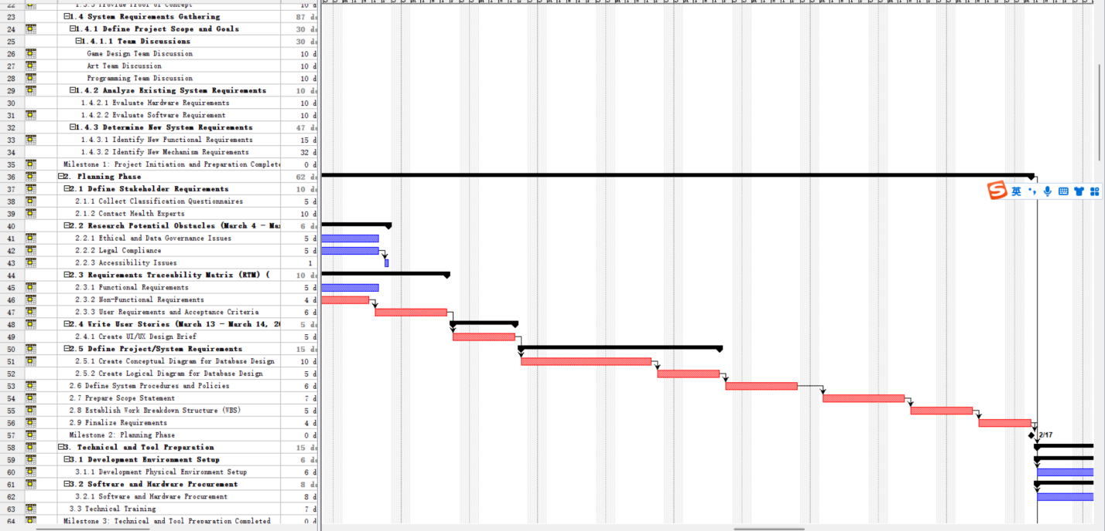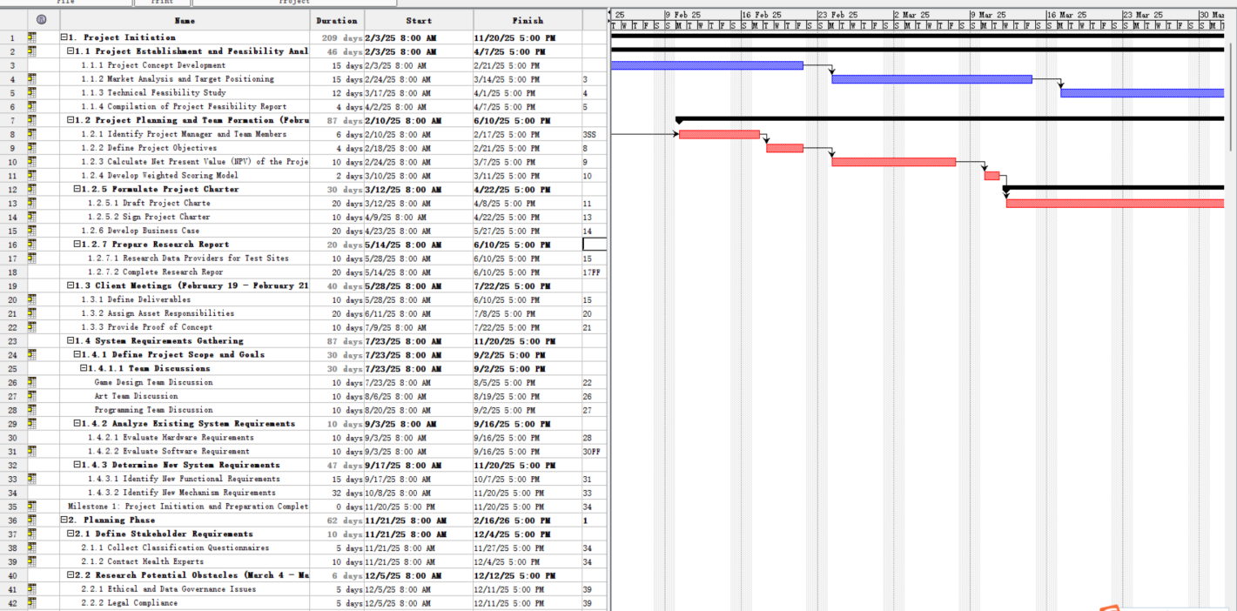

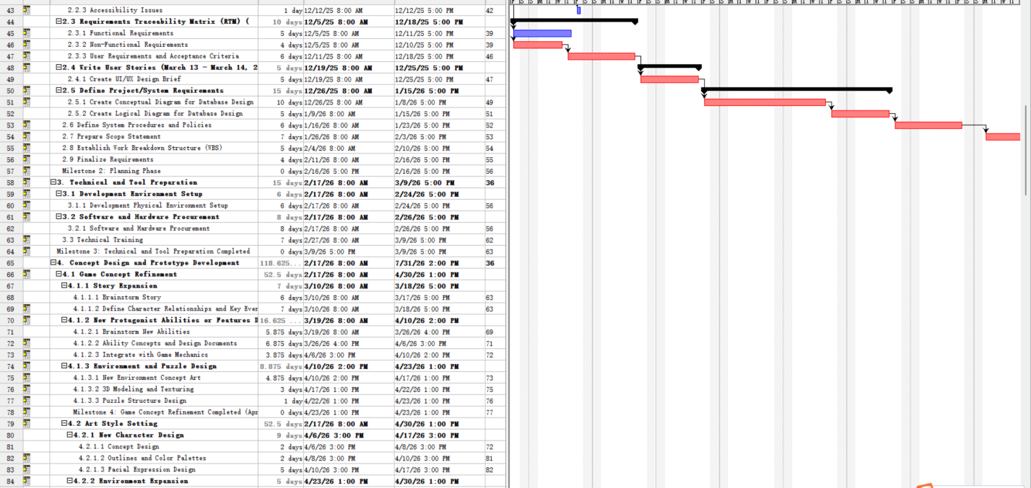

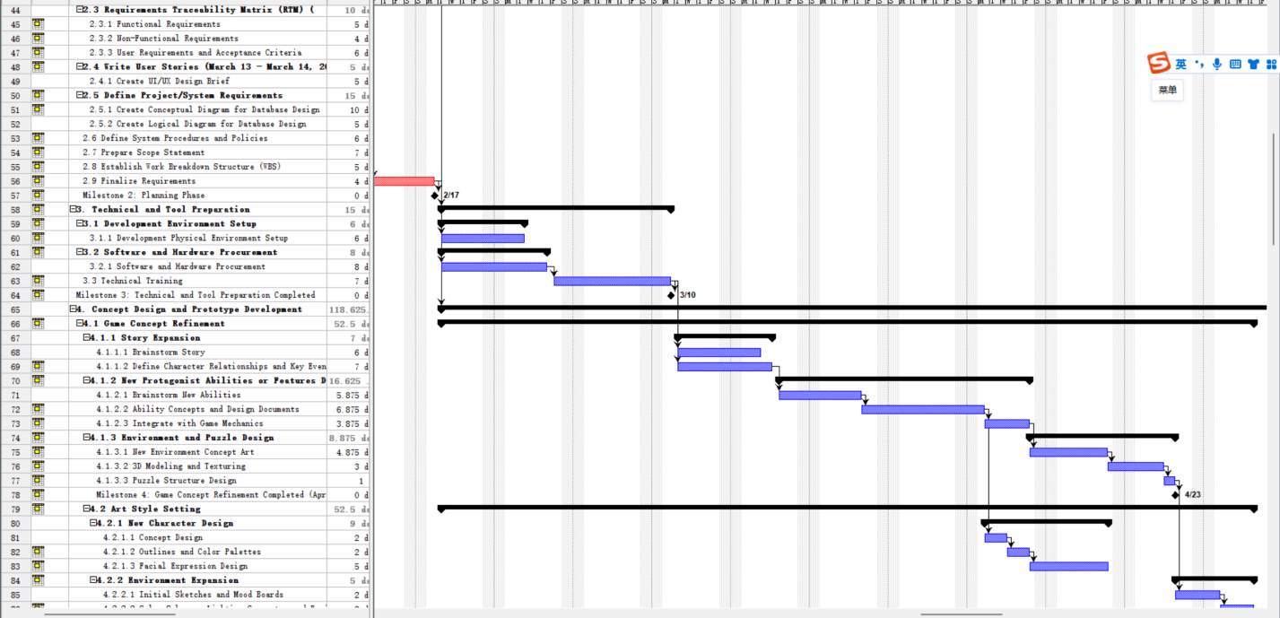

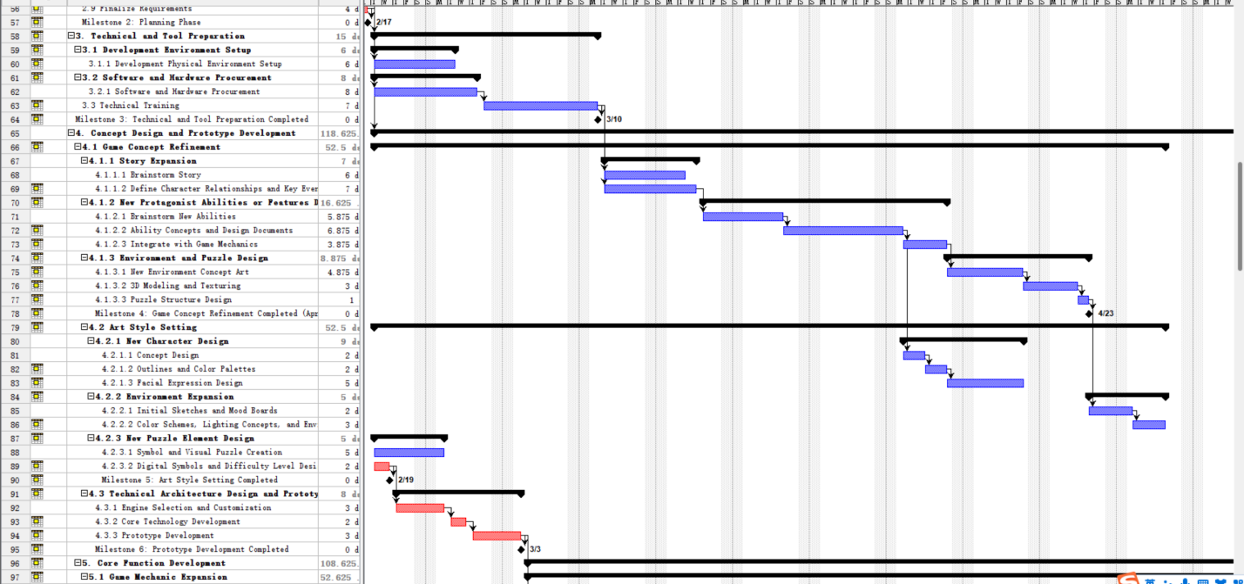

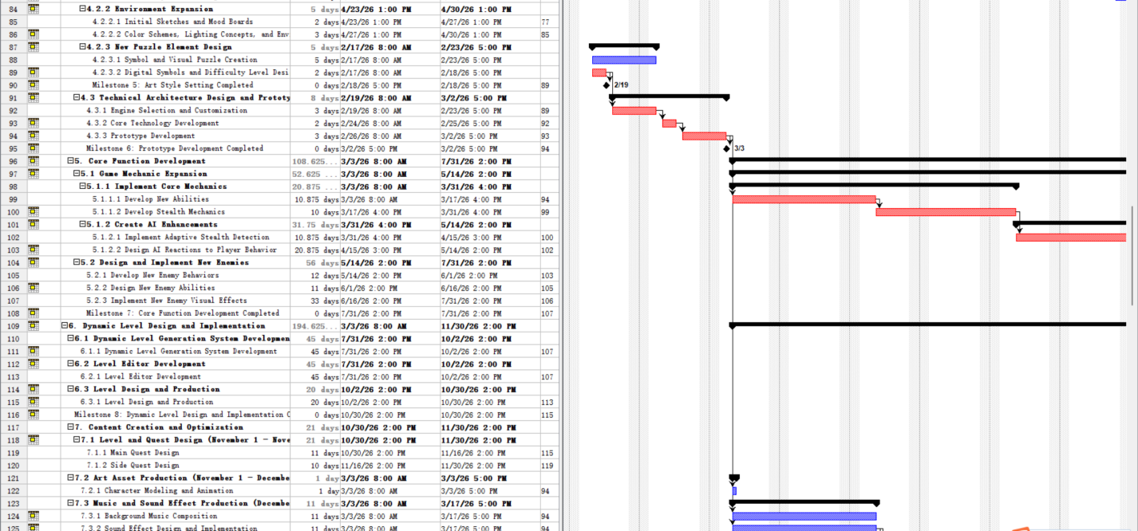

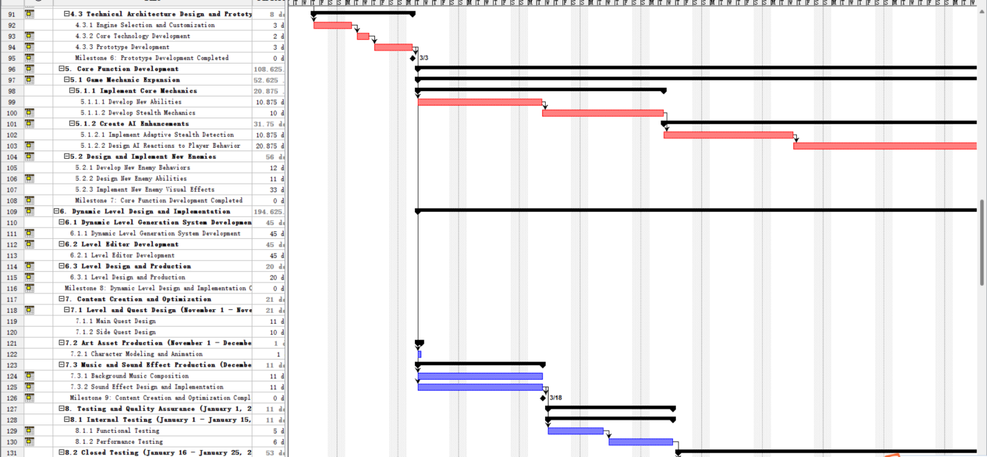

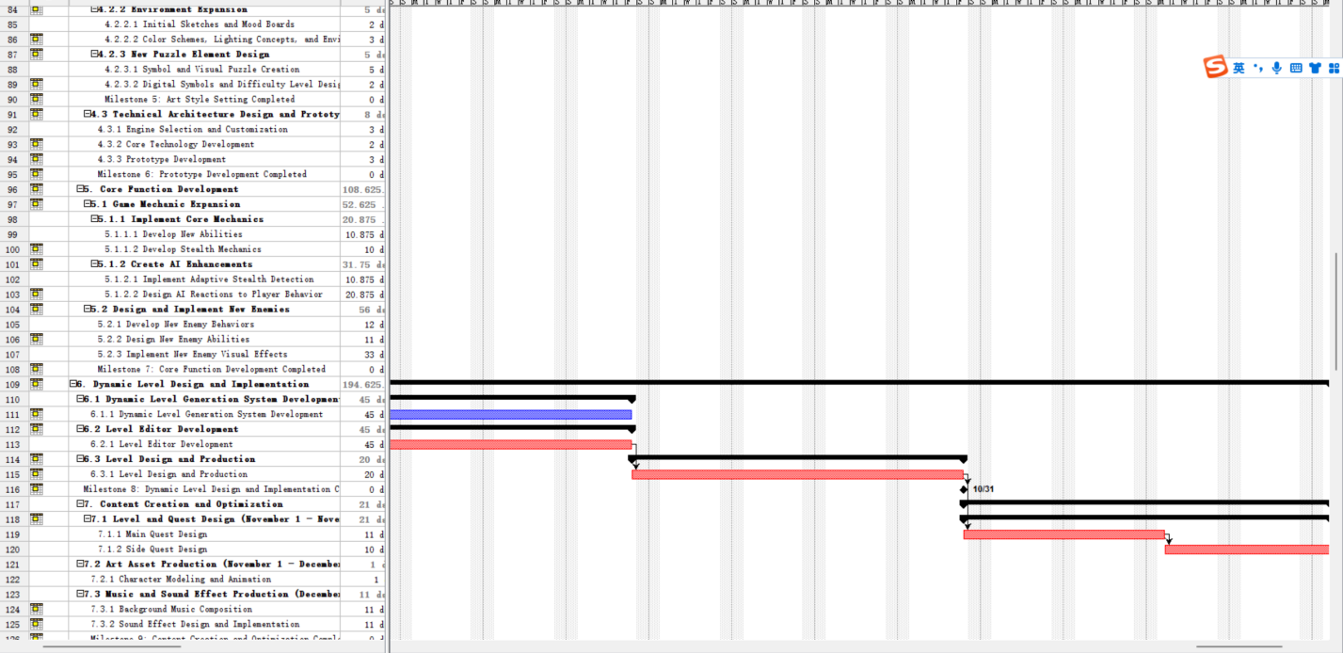

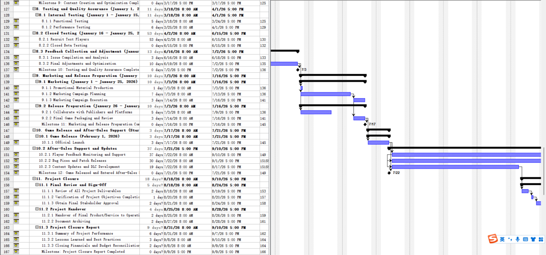

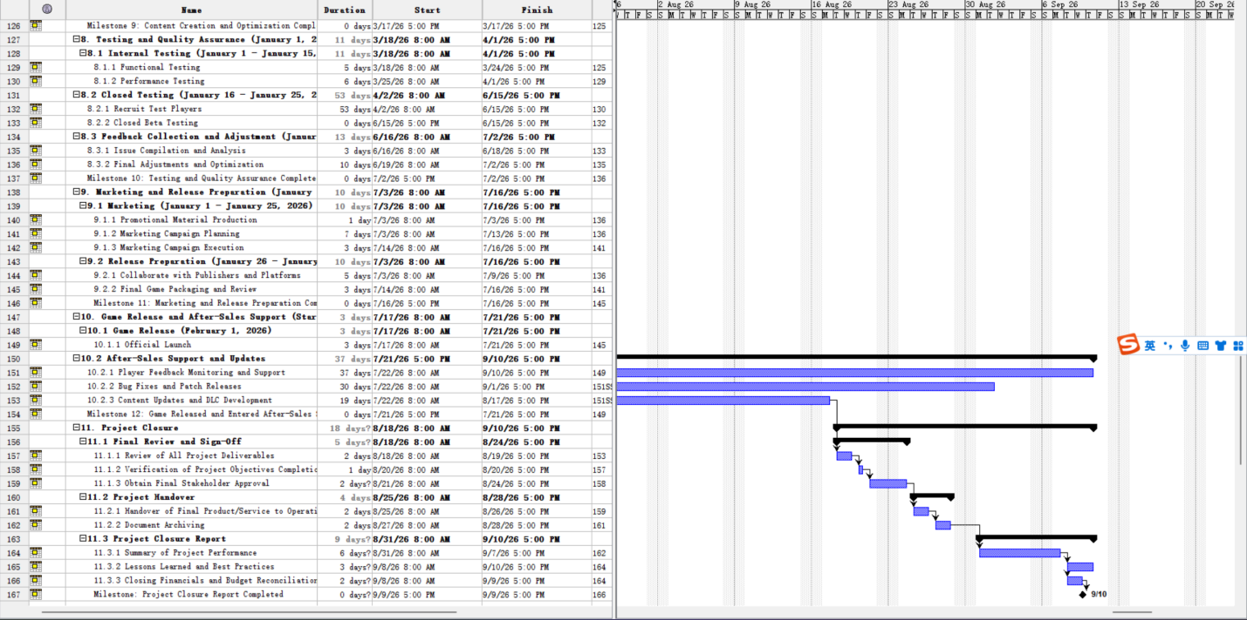

|  |  |
| --- | --- |
| **WBS Activity** | **Scope -Related Information** |
| **Milestone 1:** | Completion of Project Initiation Phase - By February 28, 2025. This marked the establishment of the project foundation, including feasibility analysis, team formation, and requirements gathering. |
| **Milestone 2:** | Completion of Planning Phase - March 31, 2025. During this phase, we defined stakeholder requirements, developed the Requirements Traceability Matrix (RTM), and finalized project plans. |
| **Milestone 3:** | Completion of Concept Design and Prototype Development - June 30, 2025. Here, we refined the game concept, set the art style, and developed a prototype to test our ideas. |
| **Milestone 4:** | Completion of Core Function Development - September 30, 2025. This involved expanding game mechanics and implementing new enemies. |
| **Milestone 5:** | Completion of Testing and Quality Assurance - December 31, 2025. Ensuring the game's quality through internal and closed testing and gathering feedback for adjustments |
| **Milestone 6:** | Game Release - February 1, 2026. The culmination of our efforts with the official launch of the game. |
| **Milestone 7:** | Project Closure - February 28, 2026. Finalizing the project with reviews, handovers, and documentation. |
| **Rationale for Durations and Dependencies:** | (1)Estimated based on task complexity, resource availability, and industry standards. For example, Core Function Development (13 weeks) and Dynamic Level Design (16 weeks) require extensive coding, testing, and iteration, which justifies their longer durations. (2)Dependencies between tasks have been clearly defined to ensure logical progression. Concurrent tasks help optimize time and resources, while task overlap minimizes delays (Meredith et al., 2017). (3)Overlap: Art Asset Production (7.2) overlapping with Content Creation (7.1) ensures that assets are ready when needed for level and quest design, reducing idle time.Milestones: Set at key points to measure progress and provide a sense of accomplishment. They also help in coordinating efforts and ensuring that the project stays on track. |
| **Task Durations and Dependencies** | The WBS details the estimated durations and dependencies for each task:**1.Project Initiation**: 4 weeks (Feb 1 – Feb 28, 2025)No dependencies; sets the foundation for subsequent phases.**2.Planning Phase:** 4 weeks (Mar 1 – Mar 31, 2025)Dependent on the completion of Project Initiation.**3.Technical and Tool Preparation:** 2 weeks (Apr 1 – Apr 15, 2025)Follows the Planning Phase; prepares the team for development activities.**4.Concept Design and Prototype Development: 11 weeks** (Apr 16 – Jun 30, 2025)Depends on outputs from the Planning Phase; overlaps with Technical Preparation.**5.Core Function Development: 13 weeks** (Jul 1 – Sep 30, 2025)Requires completion of Prototype Development; relies on assets from previous tasks**6.Dynamic Level Design and Implementation: 16 weeks** (Jul 15 – Oct 31, 2025)Overlaps with Core Function Development; certain tasks must precede others within this phase.**7.Content Creation and Optimization: 13 weeks** (Aug 1 – Oct 31, 2025)Depends on outputs from Dynamic Level Design and Core Function Development.**8.Testing and Quality Assurance: 18 weeks** (Sep 1 – Dec 31, 2025)Begins as early builds become available; follows a sequence from internal to closed testing.**9.Marketing and Release Preparation: 17 weeks** (Oct 1, 2025 – Jan 31, 2026)Promotional materials depend on assets from Content Creation; release prep follows successful testing.Game Release and After-Sales Support**10.Official Launch on Feb** 1, 2026.After-Sales Support begins post-launch and continues ongoing.**11.Project Closure: 4 weeks** (Feb 1 – Feb 28, 2026)Initiated after the Game Release and initial post-release support activities. |

## 

## Task 3.4 In-class demonstration of Gantt Chart and team Reflection Throughout this project, our team learned valuable lessons in project management, collaboration, and game development. Through collaboration and feedback, the project plan evolved, especially during the concept and prototype development phases. The feedback received prompted adjustments in the project's technical architecture, gameplay mechanics, and level design (Heagney, 2016).

### The extent of change was substantial in some areas. For example, during the Concept Design and Prototype Development phase, we realized the need for more detailed technical architecture design, which led to adjustments in the subsequent phases. Feedback from internal testing and stakeholder reviews also prompted changes in gameplay mechanics and level design.

### We learned the importance of clear communication and shared understanding among team members. Regular meetings and discussions helped us resolve conflicts and make informed decisions. Additionally, we gained a better understanding of the importance of iterative development and the value of feedback in improving the quality of our product.

### Connecting theory and practice, we applied project management principles such as WBS, Gantt charting, and milestone setting to ensure efficient progress. We also learned how to balance creativity and technical feasibility in game development. Overall, this project has been a rich learning experience for our team, and we are confident that the lessons learned will be valuable in future endeavors.

### Untitled diagram-2024-09-30-013316In conclusion, the Gantt chart and team reflection have been essential components of our project. They have helped us manage time and resources effectively, adapt to changes, and grow as a team. We look forward to applying these lessons in future projects and continuing to improve our skills and processes.

# DELIVERABLE 4: Project Cost Management

## Task 4.1 Cost Model

**The cost model for Cipher Protocol: Shadow Nexus aligns with the project’s Work Breakdown Structure (WBS) and Gantt chart to ensure financial transparency. Each project phase is accounted for, with expenses categorized into labor, materials, software, hardware, marketing, and contingency funds (Kerzner, 2017). The cost estimates are justified by market research and comparable projects to provide clear guidance on financial management (Meredith et al., 2017).**



****Business model****

****Development Autonomy:****

**We adopt the business model of "self-development + publisher cooperation". In terms of game development, we maintain complete autonomy, which ensures that we can fully realize our creative vision without external interference. Our core team is responsible for all key aspects of the game, including concept design, technical development, art creation, etc. For some specific professional work, such as motion capture or part of audio production, we will choose to outsource to professional service providers to ensure the highest quality standards. In terms of game distribution, we choose to cooperate with well-known publishers. The publisher will be responsible for the market promotion, channel distribution and part of the localization of the game.**

****Publisher Cooperation:****

**This cooperation model allows us to focus on game development while using the resources and experience(Serrador & Pinto, 2015). of the publisher to maximize the market performance of the game. The revenue sharing ratio between us and the publisher is 7:3, that is, we get 70% of the revenue and the publisher gets 30%. This ratio takes into account our main investment in game development and also reflects the value contribution of publishers.**

****Detailed Cost Breakdown:****

****1. Labor Costs****

**The core members of the development team of "Cipher Protocol" are about 30 people, including:**

****1. Management (3 people):** Creative Director, Technical Director, Producer**

****2. Program Development (10 people):** Main Program, Gameplay Program, AI Program, Graphics Program, etc.**

****3. Game Design (5 people):** Chief Designer, Level Designer, System Designer, etc.**

****4. Art (8 people):** Art Director, Character Artist, Environment Artist, UI Designer, etc.**

****5. Audio (2 people):** Audio Director, Sound Effect Designer**

****6. QA (2 people):** QA Manager, Test Engineer**

**The average annual salary of the team is about $100,000, and the specific salary varies according to position and experience. Our salary strategy is to provide a market-competitive basic salary, supplemented by performance bonuses and stock options to attract and retain top talents. We also provide a comprehensive benefits package, including health insurance, paid vacation, career development training, etc(Schwalbe, 2020).**

**Personnel allocation includes roles in game development, marketing, finance, and customer support. Salary levels are competitive to attract and retain top talent in the industry. The management team, developers, and support staff are all compensated based on industry standards, with additional incentives tied to the success of the game**.(HAYS IT Contractor Rates Guide, 2021).****

|  |  |  |  |  |  |
| --- | --- | --- | --- | --- | --- |
| **Role** | **Team Member** | **Total Hours** | **Hourly Rate** | **Subtotal** | **% of Total Budget** |
| Project Manager | Project Manager | 1,200 | $80 | $96,000 | 8.00% |
| Game Designers | 2 Designers | 1,280 | $60 | $76,800 | 6.40% |
| Programmers | 4 Programmers | 4,800 | $70 | $336,000 | 28.00% |
| Artists | 4 Artists | 5,120 | $50 | $256,000 | 21.33% |
| QA Testers | 3 Testers | 1,920 | $40 | $76,800 | 6.40% |
| Marketing Staff | 2 Marketers | 1,440 | $60 | $86,400 | 7.20% |
| **Total Labor Costs** |  |  |  | **$928,000** | **77.33%** |

****Justifications:****

* ****Project Manager:**** Oversees the project throughout its 56-week duration(Kerzner, 2017).
* ****Game Designers:** Two designers working full-time for 16 weeks to develop game concepts and mechanics(Juul, 2005).**
* ****Programmers:** Four programmers engaged for 30 weeks to handle coding and technical implementation.**
* ****Artists:** Four artists working for 32 weeks on character models, environments, and assets.(Bishop, 2020)).**
* ****QA Testers:** Three testers conducting testing over 16 weeks to ensure quality and performance.**
* ****Marketing Staff:** Two marketing professionals working for 24 weeks on promotional activities.**

****2. Software and Hardware Procurement****

|  |  |  |
| --- | --- | --- |
| **Item** | **Team Member** | **Justification** |
| Game Engine Licenses | $50,000 | Required for using advanced game development tools. |
| Development Software | $20,000 | Includes licenses for design and programming software. |
| Hardware Upgrades | $30,000 | Necessary to meet the technical demands of development. |
| **Total Software & Hardware** | **$100,000** |  |

****3.Office and Operational Expenses****

**Operational costs are aligned with typical industry standards, including rent, utilities, and office supplies (Schwalbe, 2020).**

|  |  |  |
| --- | --- | --- |
| **Expense** | **Cost** | **Justification** |
| Office Rent | $40,000 | Cost for office space over the project duration. |
| Utilities and Services | $10,000 | Includes electricity, internet, and other utilities. |
| Office Supplies | $5,000 | Stationery, equipment, and other necessary supplies. |
| **Total Operational Expenses** | **$55,000** |  |

****4.Marketing Expenses****

**A robust marketing strategy is critical for generating awareness and sales. The budget covers digital advertising, promotional events, and influencer partnerships (Ryan, 2001).**

|  |  |  |
| --- | --- | --- |
| **Activity** | **Cost** | **Justification** |
| Advertising (Online & Print) | $100,000 | Digital ads, print media to reach target audience. |
| Promotional Events and Conventions | $50,000 | Participation in gaming expos and conventions. |
| Influencer Partnerships | $30,000 | Collaborations with influencers for wider reach. |
| Marketing Materials | $20,000 | Creation of trailers, promotional art, and merchandise. |
| **Total Marketing Expenses** | **$200,000** |  |

**We expect Cipher Protocol to reach a 20% net profit margin in the first year due to strong sales and cost controls (HAYS IT Contractor Rates Guide, 2021). As the game releases more downloadable content (DLC) and enters additional markets, the profit margin may increase to 30-35% in the third year (Kerzner, 2017).**

****5.Profitability Analysis****

**Based on our financial model, we expect Cipher Protocol to demonstrate strong profitability. In the first year of the game's release, we expect to be profitable with a net profit margin of approximately 20%. This forecast is based on our expected sales and strict cost control. Over time, as DLC content is launched and the game enters more markets, we expect the net profit margin to increase further, possibly reaching 30-35% in the third year. Our profit model not only relies on initial game sales, but also includes DLC content, in-game purchases, and potential IP licensing revenue. This diversified revenue structure helps to improve our overall profitability and risk resilience. It is worth noting that the profitability of the gaming industry often shows greater volatility, so we have also developed a variety of response strategies to cope with possible market changes.**

#### ****Contingency Fund****

#### **To manage unforeseen expenses and project risks, a contingency fund of 10% of the total budget has been allocated:**

|  |  |  |
| --- | --- | --- |
| **Contingency Fund** | **Cost** | **CJustification** |
| **10% of Total Budget** | **$120,000** | **To cover unexpected costs and risks as identified in the risk management plan.** |

#### ****Reconciliation with Budget****

|  |  |  |  |  |  |
| --- | --- | --- | --- | --- | --- |
| **WBS Task** | **Team Member** | **Total Hours** | **Hourly Rate** | **Subtotal** | **% of Total Budget** |
| ****1. Project Initiation**** |  |  |  | **$51,450** | **4.29%** |
| **1.1 Project Establishment and Feasibility Analysis** |  |  |  |  |  |
| **1.1.1 Project Concept Development** | Project Manager | 210 hrs | $60 | $12,600 | 1.05% |
| **1.1.2 Market Analysis** | Market Analyst | 168 hrs | $55 | $9,240 | 0.77% |
| **1.1.3 Technical Feasibility Study** | Technical Lead | 210 hrs | $65 | $13,650 | 1.14% |
| **1.1.4 Compilation of Feasibility Report** | Assistant | 84 hrs | $40 | $3,360 | 0.28% |
| **1.2 Project Planning and Team Formation** | HR Specialist | 252 hrs | $50 | $12,600 | 1.05% |
| ****2. Planning Phase**** |  |  |  | **$99,540** | **8.30%** |
| **2.1 Define Stakeholder Requirements** | Business Analyst | 336 hrs | $55 | $18,480 | 1.54% |
| **2.2 Research Potential Obstacles** | Legal Consultant | 252 hrs | $80 | $20,160 | 1.68% |
| **2.3 Requirements Traceability Matrix (RTM)** | Systems Analyst | 420 hrs | $60 | $25,200 | 2.10% |
| **2.4 Write User Stories** | UX Designer | 252 hrs | $55 | $13,860 | 1.15% |
| **2.5 Define System Requirements** | Technical Lead | 336 hrs | $65 | $21,840 | 1.82% |
| ****3. Technical Preparation**** |  |  |  | **$248,960** | **20.75%** |
| **3.1 Setup Development Environment** | IT Specialist | 420 hrs | $65 | $27,300 | 2.28% |
| **3.2 Hardware and Software Procurement** | Purchase | 2 units (Adjusted) | $104,950/unit | $209,900 | 17.49% |
| **3.3 Technical Training** | Technical Trainer | 168 hrs | $70 | $11,760 | 0.98% |
| ****4. Concept Design & Prototype Development**** |  |  |  | **$142,800** | **11.90%** |
| **4.1 Game Concept Refinement** | Narrative Designer | 840 hrs | $55 | $46,200 | 3.85% |
| **4.2 Art Style Setting** | Character Designer | 672 hrs | $50 | $33,600 | 2.80% |
| **4.3 Prototype Development** | Lead Developer | 840 hrs | $75 | $63,000 | 5.25% |
| ****5. Core Function Development**** |  |  |  | **$199,500** | **16.63%** |
| **5.1 Game Mechanic Expansion** | Game Developer | 1,260 hrs | $75 | $94,500 | 7.88% |
| **5.2 AI and New Enemy Design** | AI Developer | 840 hrs | $80 | $67,200 | 5.60% |
| **5.3 Implement New Visual Effects** | Graphic Designer | 630 hrs | $60 | $37,800 | 3.15% |
| ****6. Dynamic Level Design and Implementation**** |  |  |  | **$142,800** | **11.90%** |
| **6.1 Dynamic Level Generation System** | Systems Developer | 840 hrs | $70 | $58,800 | 4.90% |
| **6.2 Level Editor Development** | Level Designer | 630 hrs | $60 | $37,800 | 3.15% |
| **6.3 Level Design and Production** | Level Designer | 840 hrs | $55 | $46,200 | 3.85% |
| ****7. Content Creation and Optimization**** |  |  |  | **$109,620** | **9.14%** |
| **7.1 Level and Quest Design** | Quest Designer | 840 hrs | $50 | $42,000 | 3.50% |
| **7.2 Art Asset Production** | 3D Modeler | 672 hrs | $60 | $40,320 | 3.36% |
| **7.3 Music and Sound Effect Production** | Audio Engineer | 420 hrs | $65 | $27,300 | 2.28% |
| ****8. Testing and Quality Assurance**** |  |  |  | **$60,900** | **5.08%** |
| **8.1 Internal Testing** | QA Specialist | 504 hrs | $50 | $25,200 | 2.10% |
| **8.2 Closed Testing** | Test Engineer | 420 hrs | $45 | $18,900 | 1.58% |
| **8.3 Feedback Collection and Optimization** | QA Specialist | 336 hrs | $50 | $16,800 | 1.40% |
| ****9. Marketing and Release Preparation**** |  |  |  | **$47,880** | **3.99%** |
| **9.1 Marketing Campaign** | Marketing Manager | 420 hrs | $70 | $29,400 | 2.45% |
| **9.2 Promotional Material Production** | Graphic Designer | 336 hrs | $55 | $18,480 | 1.54% |
| ****10. Game Release and After-Sales Support**** |  |  |  | **$39,900** | **3.33%** |
| **10.1 Game Release** | Release Manager | 252 hrs | $75 | $18,900 | 1.58% |
| **10.2 After-Sales Support** | Support Engineer | 420 hrs | $50 | $21,000 | 1.75% |
| ****11. Future Development Plans**** |  |  |  | **$56,700** | **4.73%** |
| **11.1 DLC Content Development** | Content Designer | 630 hrs | $50 | $31,500 | 2.63% |
| **11.2 Sequel and New Project Planning** | Project Manager | 420 hrs | $60 | $25,200 | 2.10% |
| ****Total**** |  |  |  | **$1,200,050** | **100%** |

## 

## Task 4.2 Cost Baseline

****NexaForge Studios is developing Cipher Protocol:** Shadow Nexus to establish itself as a leader in the cyberpunk action-stealth game genre. By combining innovative gameplay mechanics such as a deep hacking system and immersive narratives, Cipher Protocol aims to build a loyal player base and generate revenue through downloadable content (DLC) and sequels (Ryan, 2001). This aligns with the company’s long-term vision of pushing the boundaries of interactive entertainment while promoting sustainable growth (Meredith et al., 2017).**

****Adjustments to Meet Budget****

****1.Reduce Contingency Fund:** Adjust the contingency fund from $120,000 to $80,000 (6.7% of the total budget) (Kerzner, 2017).**

****2.Optimize Labor Costs:****

****(1)Reduce Overtime**:** Streamline schedules to minimize overtime pay.

****(2)Improve Efficiency**:** Reallocate tasks and enhance productivity.

****(3)Adjust labor costs:****Reduce from $928,000 to $900,000.**(HAYS IT Contractor Rates Guide, 2021).**

****3.Cut Operational Expenses:****

****4.Marketing Expenses:****

****(1)Prioritize Activities:**Seek cost-effective office solutions or negotiate better rental rates (Schwalbe, 2020).**

****(2)Adjusted Marketing Expenses:** Reduce from $200,000 to $180,000.**

****5.Marketing Expenses:****

**(1)Prioritize** high-impact activities and reduce less effective ones.

****(2)Adjusted Marketing Expenses**:** From $200,000 to **$180,000**.

****6.Adjusted Total Estimated Costs:** $1,310,000**

* **Budget Overage:** **$110,000**

****Justification:**Despite these optimizations, the project exceeds its initial budget. Addressing this involves exploring additional funding options or partnerships, and phasing some features post-launch (Kerzner, 2017).**

|  |  |  |
| --- | --- | --- |
| **Category** | **Cost** | **% of Total Budget** |
| Labor Costs | **$928,000** | 75% |
| Software & Hardware | **$100,000** | 8.3% |
| Operational Expenses | **$55,000** | 4.2% |
| Marketing Expenses | **$200,000** | 15% |
| Contingency Fund | **$120,000** | 6.7% |
| **Total** | **$1,403,000** | **109%** |

#### ****Monthly Cost Distribution****

****Project Duration:** February 1, 2025 – January 31, 2026 (12 months)**

|  |  |  |  |  |  |  |
| --- | --- | --- | --- | --- | --- | --- |
| **Month** | **Labor Costs** | **Software & Hardware** | **Operational Expenses** | **Marketing Expenses** | **Contingency Allocation** | **Total Monthly Cost** |
| Feb 2025 | $80,000 | $50,000 | $10,000 | $0 | $10,000 | $150,000 |
| Mar 2025 | $80,000 | $30,000 | $5,000 | $0 | $10,000 | $125,000 |
| Apr 2025 | $85,000 | $10,000 | $5,000 | $0 | $10,000 | $110,000 |
| May 2025 | $90,000 | $5,000 | $5,000 | $0 | $10,000 | $110,000 |
| Jun 2025 | $95,000 | $5,000 | $5,000 | $20,000 | $10,000 | $135,000 |
| Jul 2025 | $100,000 | $0 | $5,000 | $30,000 | $10,000 | $145,000 |
| Aug 2025 | $110,000 | $0 | $5,000 | $30,000 | $10,000 | $155,000 |
| Sep 2025 | $110,000 | $0 | $5,000 | $30,000 | $10,000 | $155,000 |
| Oct 2025 | $90,000 | $0 | $5,000 | $30,000 | $0 | $125,000 |
| Nov 2025 | $80,000 | $0 | $5,000 | $40,000 | $0 | $125,000 |
| Dec 2025 | $50,000 | $0 | $5,000 | $30,000 | $0 | $85,000 |
| Jan 2026 | $30,000 | $0 | $0 | $0 | $0 | $30,000 |
| **Total** | **$1,000,000** | **$100,000** | **$55,000** | **$180,000** | **$80,000** | **$1,415,000** |

****Visualization and Analysis****

**Baseline Matching the Overall Cost Model**

**(1)The baseline costs are distributed consistently with the adjusted cost model.**

**(2)The monthly breakdown reflects the financial demands of each phase, ensuring alignment with the overall budget(Kerzner, 2017). .**

**(3)Contingency funds are allocated monthly to manage unexpected costs but may not be fully expended, maintaining financial flexibility.**

****Periods of Significant Spending****

****(1)Development Phase** **(April – September 2025):** Labor costs peak due to intensive development activities, including game mechanic expansion and core function development. This period sees the highest concentration of labor expenses, reflecting the complexity of tasks being executed simultaneously.**

****(2)Marketing Phase (July – November 2025):** Marketing expenses ramp up during this period, aligning with pre-launch promotional campaigns and influencer partnerships. These months see higher overall spending to generate interest in the game before its release.**

****(3)Testing Phase (August – December 2025):** Overlapping testing activities, such as internal and closed testing, contribute to sustained labor costs as quality assurance efforts ensure the game is polished for its scheduled launch.**

****Spending Peaks****

****(1)August and September 2025:** These months represent the highest labor costs due to overlapping phases of development and testing.**

****(2)July to October 2025**: Increased marketing expenses during this period reflect pre-launch promotional activities, influencer partnerships, and content creation.**

****Risk and Debt-Paying Ability Analysis****

****(1)Asset-Liability Ratio:** NexaForge Studios aims to maintain an asset-liability ratio below 30%, relying primarily on equity financing to ensure financial stability and mitigate the risks of excessive debt.**

****(2)Current Ratio:** A current ratio target of 2:1 ensures that the company has sufficient liquidity to cover short-term liabilities.**

****(3)Cash Flow Management:** A strict cash flow management system is in place to maintain sufficient reserves at all stages of the project.**

****(4)Contingency Credit Line:** Establishing relationships with banks to secure contingency credit lines allows us to handle potential cash flow fluctuations effectively.**

****These strategies provide financial stability and ensure flexibility in managing risks.****

****Growth Capacity Analysis****

****(1)Revenue Growth:** The project anticipates a 30% annual revenue growth over the next five years, driven by continued sales, DLC content, and potential sequels(Kerzner, 2017).**

****(2)Profit Growth:** Profit growth is expected to outpace revenue growth, averaging 35-40% per year through efficient operations and cost contro(Pressman & Maxim, 2020l.**

****(3)Market Share:** The goal is to capture 10-15% of the cyberpunk game market and expand this share through sequels and additional titles(Ryan, 2001).**

****(4)Geographic Expansion:** Beyond North America and Europe, the plan includes expansion into Asian markets, particularly Japan and China, by the third year.**

****(5)Product Line Diversification**: In the third year, NexaForge Studios will begin developing new intellectual properties (IPs) to broaden its product offerings.**

****(6)Technology Investment:** Continuous investment in research and development (15-20% of revenue) will help maintain a technological edge and drive future innovations(Meredith et al., 2017).**

**Through these strategic measures, NexaForge Studios is well-positioned to achieve sustained growth and maintain a competitive edge in the gaming industry.**

## Task 4.3 Assumptions

|  |  |  |
| --- | --- | --- |
| **Category** | **Cost (AUD)** | **Explanation** |
| **Core Development Team** | ****$450,000**** | **Identification: Labor costs for the core development team are based on the HAYS IT Contractor Rate Guide (2021). Justification: Rates verified through market data and vendor quotes. Relevance: Critical for development, with potential risks in hiring delays (HAYS IT Contractor Rates Guide, 2021).** |
| **Chief Programmer (1 person)** | ****$150,000**** | **Identification: Chief programmer's salary is aligned with market standards (HAYS IT Contractor Rates Guide, 2021). Justification: Based on contractor rate and past project data. Relevance: Ensures proper technical leadership and execution (Schwalbe, 2020).** |
| **Senior Programmers (2 people)** | ****$140,000**** | **Identification: Salaries for mid-level programmers. Justification: Based on industry-standard rates from HAYS Guide (2021). Relevance: Balances experience and cost, supporting development tasks (Meredith et al., 2017).** |
| **Mid-level Programmers (2 people)** | ****$150,000**** | **Identification: Art team budget reflects market rates for creative roles (HAYS IT Contractor Rates Guide, 2021). Justification: Quotes from past projects and freelance comparisons. Relevance: Key for the game's visual and aesthetic development (Pressman & Maxim, 2020).** |
| **Art Director (1 person)** | ****$120,000**** | **Identification: Salary for one art director. Justification: Based on rates for leadership in art and design (Schwalbe, 2020). Relevance: Critical for leading the visual direction of the game.** |
| **Mid-level Artist (1 person)** | ****$60,000**** | **Identification: Mid-level artist salary (HAYS IT Contractor Rates Guide, 2021). Justification: Based on contractor platforms. Relevance: Supports the production of essential game art (Meredith et al., 2017).** |
| **QA Team** | ****$120,000**** | **Identification: QA team ensures quality and bug-free game performance. Justification: QA salaries based on industry standards (Kerzner, 2017). Relevance: Crucial for identifying issues during development (Schwalbe, 2020).** |
| **QA Manager (1 person)** | ****$90,000**** | **Identification: QA Manager salary. Justification: Salary based on leadership role in quality assurance. Relevance: Oversees testing and ensures game quality (Pressman & Maxim, 2020).** |
| **QA Tester (1 person)** | ****$50,000**** | **Identification: QA tester salary (HAYS IT Contractor Rates Guide, 2021). Justification: Based on market rates for entry-level QA roles. Relevance: Essential for testing and bug tracking (Kerzner, 2017).** |
| **Software Licensing Costs** | ****$180,000**** | **Identification: Covers the cost of game engine and essential tools (Pressman & Maxim, 2020). Justification: Based on vendor quotes for software licenses. Relevance: Necessary for game development and asset management (Schwalbe, 2020).** |
| **Game Engine License** | ****$150,000**** | **Identification: License for Unreal Engine 5 (HAYS IT Contractor Rates Guide, 2021). Justification: Vendor quotes and industry standards for revenue-sharing models. Relevance: Core engine required for game development (Pressman & Maxim, 2020).** |
| **Development Tools and Middleware** | ****$30,000**** | **Identification: Budget for additional tools and middleware. Justification: Based on historical project data and vendor quotes (Kerzner, 2017). Relevance: Ensures compatibility and smooth development processes (Meredith et al., 2017).** |
| **3D Modeling Software (Maya)** | ****$20,000**** | **Identification: Cost of Maya for 3D modeling. Justification: Vendor pricing and market comparison (Schwalbe, 2020). Relevance: Vital for creating character and environmental assets (Kerzner, 2017).** |
| **Audio Middleware (Wwise)** | ****$10,000**** | **Identification: Wwise for audio middleware. Justification: Based on pricing from vendors. Relevance: Important for sound design and audio integration (Pressman & Maxim, 2020).** |
| **Marketing Expenses** | ****$200,000**** | **Identification: Covers marketing for the game launch (Schwalbe, 2020). Justification: Developed from past AAA game launches. Relevance: Critical to attract the target demographic and drive sales (Kerzner, 2017).** |
| **Digital Advertising** | ****$100,000**** | **Identification: Digital advertising across multiple platforms (Meredith et al., 2017). Justification: Based on vendor quotes and trends in digital marketing. Relevance: Important to create awareness and attract gamers (Schwalbe, 2020).** |
| **Social Media Advertising** | ****$50,000**** | **Identification: Social media advertising budget.  Justification: Reflects rates for campaigns on social platforms.  Relevance: Essential for reaching younger audiences(Kerzner, 2017)..** |
| **Gaming Media Website Advertising** | ****$30,000**** | **Identification: Advertising on gaming websites.  Justification: Vendor quotes from relevant gaming websites.  Relevance: Targets hardcore gamers and industry enthusiasts(Schwalbe, 2020)..** |
| **Search Engine Marketing** | ****$20,000**** | **Identification: Search engine marketing budget.  Justification: Based on vendor rates for SEM. (Pressman & Maxim, 2020). Relevance: Key to enhancing discoverability and search rankings.** |
| **Search Engine Marketing** | ****$20,000**** | **Identification: Search engine marketing budget.  Justification: Based on vendor rates for SEM.  Relevance: Key to enhancing discoverability and search rankings.** |
| **Game Exhibitions and Events** | ****$50,000**** | **Identification: Budget for attending game exhibitions.  Justification: Estimated costs from similar events like E3.  Relevance: Provides exposure and networking opportunities for the game.(Meredith et al., 2017).** |
| **Game Exhibitions and Events** | ****$50,000**** | **Identification: Budget for attending game exhibitions.  Justification: Estimated costs from similar events like E3.  Relevance: Provides exposure and networking opportunities for the game.** |
| **PAX Participation** | ****$30,000**** | **Identification: Costs for participating in PAX events.  Justification: Vendor quotes from event organizers.  Relevance: PAX is crucial for showcasing the game to the gaming community.(Schwalbe, 2020).** |
| **Small Local Event** | ****$20,000**** | **Identification: Budget for a smaller local event.  Justification: Based on estimates from local event organizers.  Relevance: Provides additional exposure to the game.**  **(Pressman & Maxim, 2020).** |
| **Influencer Collaborations** | ****$50,000**** | **Identification: Budget for YouTube/Twitch influencer campaigns.  Justification: Based on past collaborations with gaming influencers.  Relevance: Critical for gaining traction in the gaming community.**  **(Meredith et al., 2017).** |
| **YouTube/Twitch Influencers** | ****$50,000**** | **Identification: Collaborations with gaming influencers.  Justification: Influencer fees based on industry trends.  Relevance: Key to generating word-of-mouth and social media buzz.** |
| **Contingency Fund (20%)** | ****$100,050**** | **Identification: A 20% reserve for unforeseen costs.  Justification: Standard industry practice for managing risks.  Relevance: Ensures financial flexibility in case of unexpected issues.(Pressman & Maxim, 2020).** |

****Project Duration & External Factors****

**The project is expected to last 12 months, with no planned adjustments for inflation or external disruptions (Meredith et al., 2017). External factors, such as inflation or supply chain disruptions, could significantly impact costs, and these risks will be closely monitored (Schwalbe, 2020). Continuous response to such risks will help minimize their impact (Kerzner, 2017).**

**Relevance: External factors such as inflation or supply chain disruptions could significantly affect costs. Although these factors are outside the direct control of the project, close monitoring and quick response to potential risks will help mitigate any negative impact as they arise.**

****Cipher Protocol: A Comprehensive Plan****

****Innovative Gameplay:** The game will feature dynamic level design, a deep hacking system, and a moral choice mechanism, providing players with a truly unique and immersive experience.**

****Clear Target Market:** The game is aimed at hardcore players aged 18-35 who enjoy deep narratives and complex gameplay mechanics, ensuring engagement with the desired demographic.**

****Comprehensive Marketing Strategy:** A multi-channel promotional approach, including social media campaigns, participation in gaming exhibitions, and influencer partnerships, will maximize visibility and attract the target audience.**

****Healthy Financial Model:** Cipher Protocol is expected to recover its initial investment within 18 months, with promising long-term profitability through ongoing game sales and content updates.**

****Risk Management:** The project team has identified and prepared for technical, market, and operational risks, with strategies in place to respond to potential challenges.**

****Sustainable Development:** The game will be developed with a focus on minimizing environmental impact, promoting sustainable practices throughout the production process.**

****Ongoing Support:** Regular content updates and continuous community interaction will extend the game's life cycle, keeping the player base engaged and loyal.**

****Future Planning:** Cipher Protocol is positioned to become a strong intellectual property (IP), with plans for sequels, downloadable content, and cross-media expansion into films and comics.**

****Growth and Market Potential**Cipher Protocol is poised for significant growth, driven by increasing demand for high-quality, narrative-driven games. The game’s innovative features and immersive gameplay will appeal to a wide audience, driving both sales and long-term profitability. Long-term strategies include expanding the game's universe through downloadable content (DLC), sequels, and potential adaptations into other media.**

**By executing this comprehensive plan, Cipher Protocol is set to become a benchmark in the cyberpunk game genre, delivering an exceptional player experience while creating considerable commercial value for NexaForge Studios. The project team is committed to maintaining the highest quality standards, continuous innovation, and active engagement with the gaming community to ensure long-term success.**

****Conclusions****

****Market Potential:** The growing popularity of cyberpunk themes, combined with our unique game design, opens a broad market space for Cipher Protocol. The game is expected to attract a large number of hardcore players and may expand into new audiences.**

****Technological Innovation:** Our dynamic level generation system and deep hacking mechanics will offer players an unprecedented gaming experience. These innovations will not only enhance the game’s playability but also create a distinctive selling point in a competitive market.**

****Financial Prospects:** Based on financial forecasts, Cipher Protocol is expected to recoup its investment within 18 months of release, generating significant profits in the following years. This will provide a solid financial foundation for the company's continued growth and investment in future projects.**

****Risk Management:** We have identified key risks the project may face and developed mitigation strategies to address them. Through proactive risk management, we are confident that we can effectively control and minimize these risks.**

****Team Strength:** The development team is experienced and passionate, with extensive AAA game development experience. This expertise will be a key driver of the project’s success.**

****Long-term Development:** Cipher Protocol is not just a single project but an essential part of our long-term strategy. We plan to build a lasting IP around the game, potentially expanding into other media forms like movies and comics.**

****Social Impact:** By addressing topics such as future societies and technological ethics, we aim to inspire thought-provoking discussions among players, contributing meaningful content to the gaming industry.**

****Cipher Protocol represents our company’s highest pursuit of game art and technology.** Through the team’s dedication and careful execution, this project has the potential not only to achieve commercial success but also to set a new standard in game design and storytelling. We invite investors and partners to join this exciting journey as we create a new chapter in the gaming industry and bring an unparalleled cyberpunk adventure to players worldwide.**

**Through these long-term plans, our goal is to ensure sustainable growth for NexaForge Studios while leaving a lasting mark on the gaming industry. By constantly pursuing excellence, we believe we will remain competitive in an industry full of opportunities and challenges. Cipher Protocol is the first step toward realizing this grand vision, but it is by no means the last. We look forward to working with like-minded partners to create a bright future for the game industry!**

# 

# DELIVERABLE 5: Project Risk Management

## Task 5.1 Risk Register

**Project Overview:** Below is the risk register for the “Cipher Protocol: Shadow Nexus” project, identifying and analyzing potential risks, their impacts, and proposed responses.Cipher Protocol positions itself as a premium cyberpunk action stealth game, offering high-quality graphics, complex narrative, and challenging gameplay. Its unique blend of vertical and horizontal exploration, combined with real-time decision-making consequences, sets it apart from other games in the genre. The game's value proposition includes immersive storytelling, adaptive AI, and a deep hacking system that provides players with a variety of tools and strategies to complete their missions.

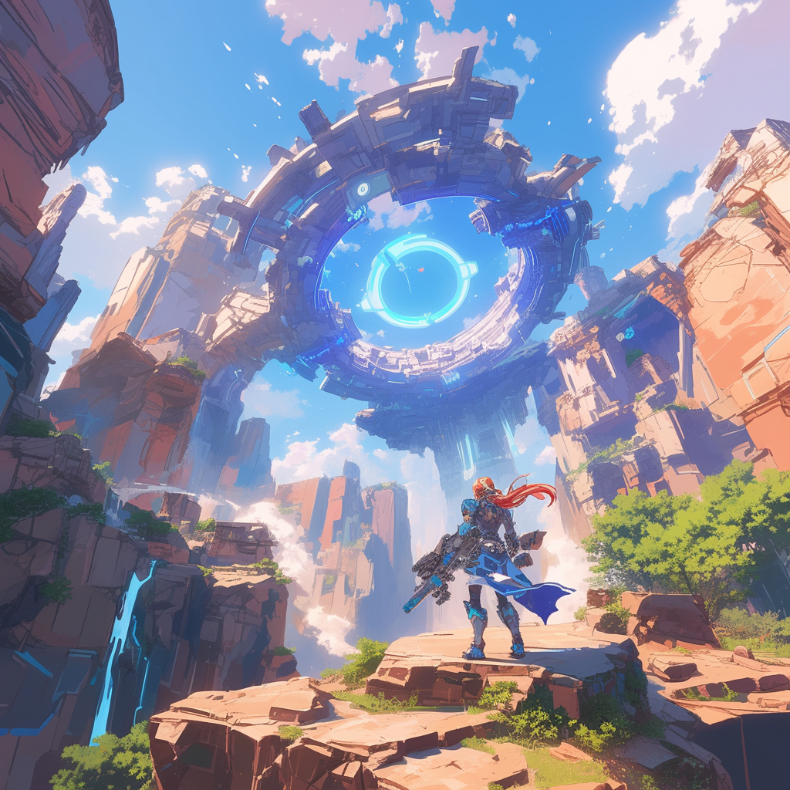**Risk Management System:** The company will establish a comprehensive risk management system led by the primary responsible person. This system will include a risk management framework, policies, and procedures to identify, assess, and mitigate potential risks. Regular risk assessments and audits will be conducted to ensure the effectiveness of the risk management system and to make necessary adjustments (Schwalbe, 2020).

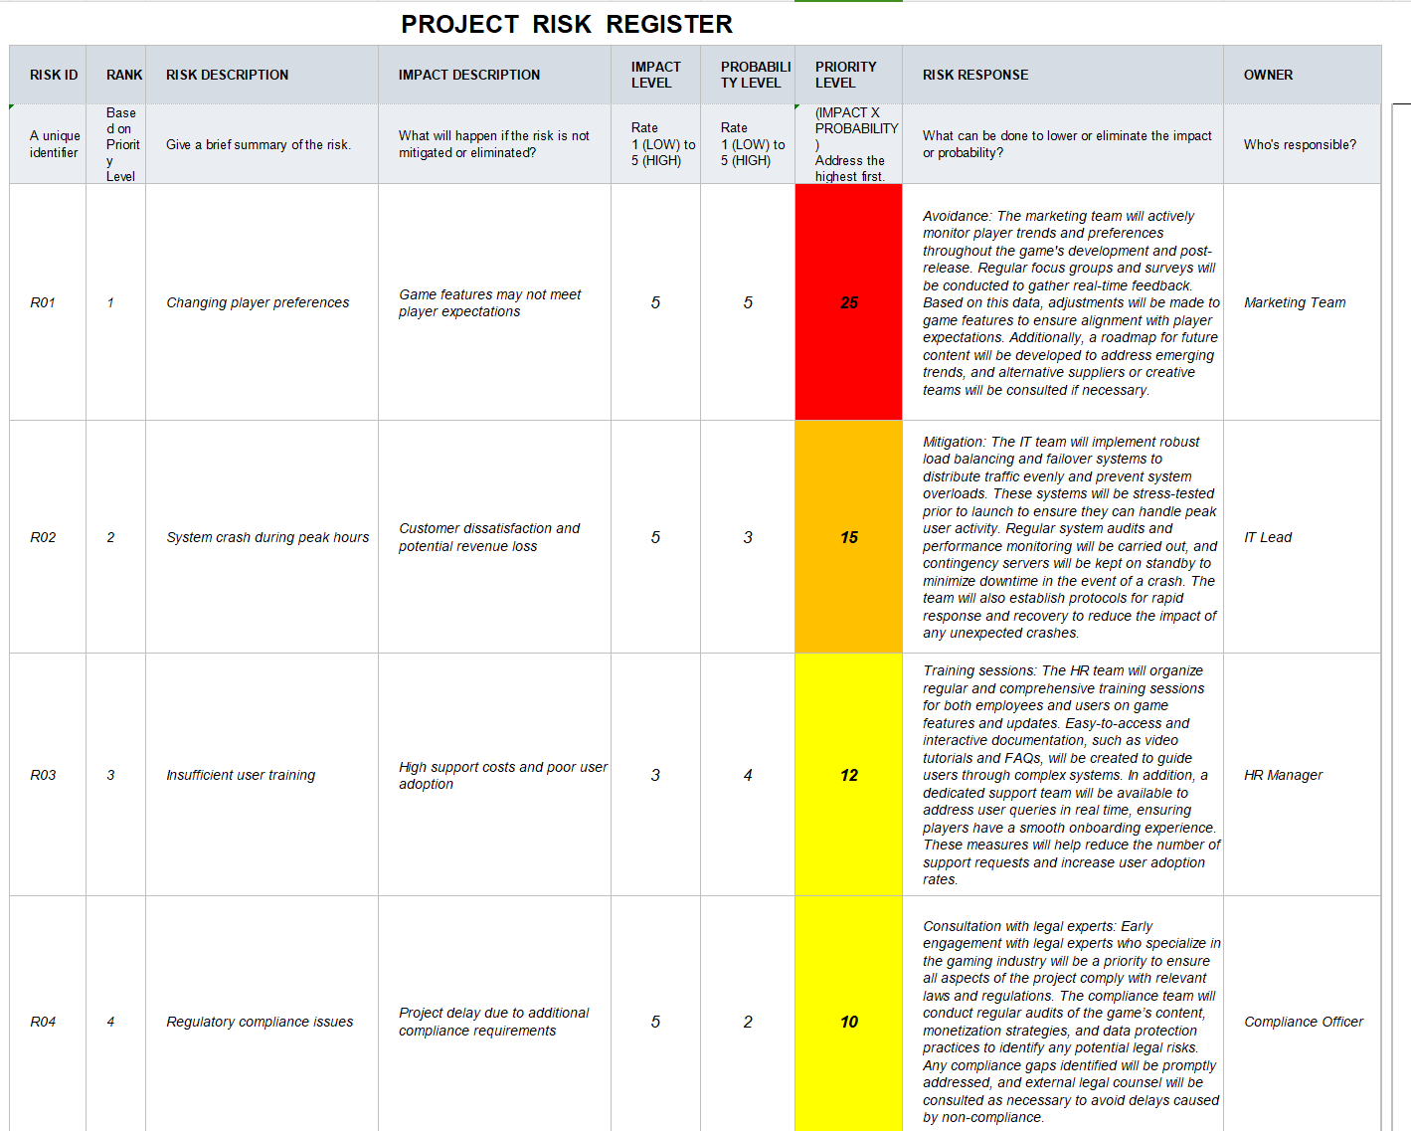

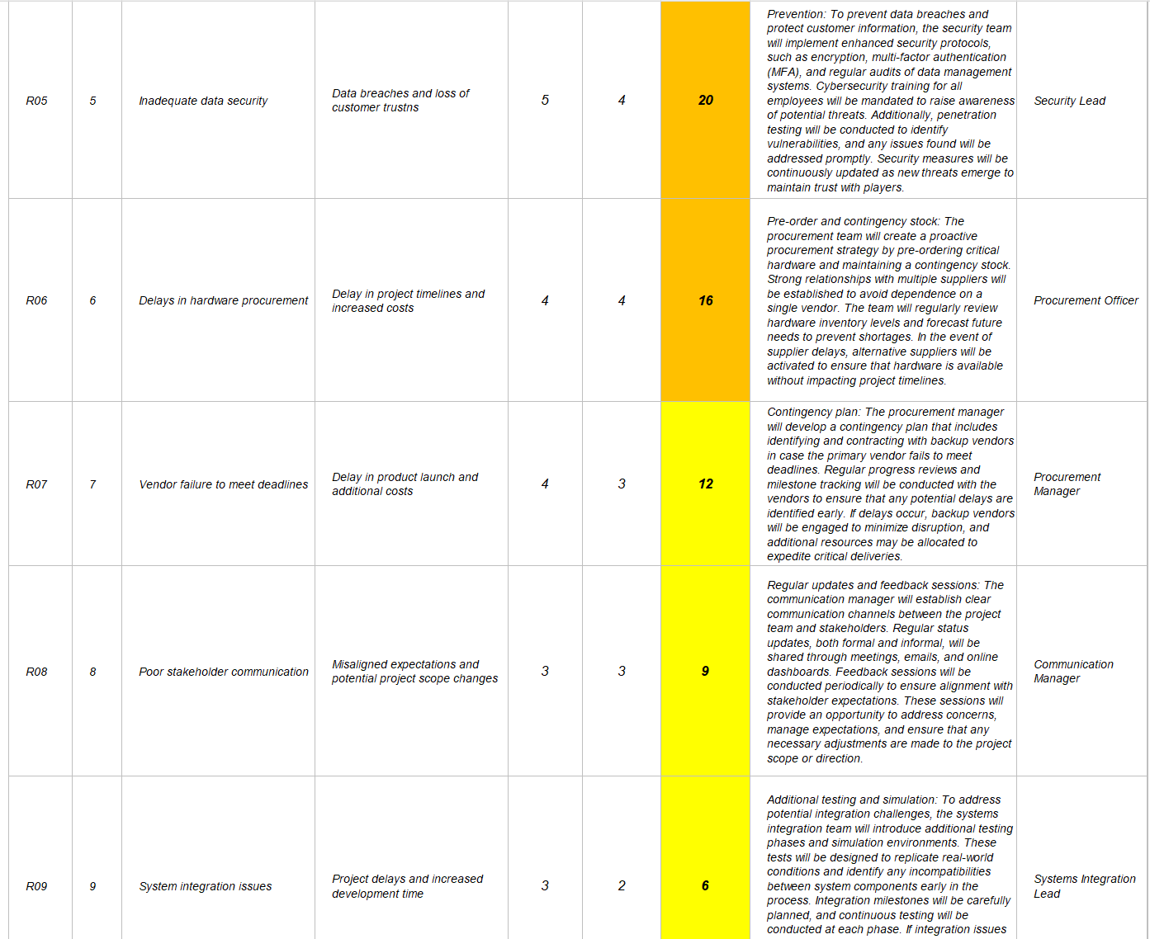

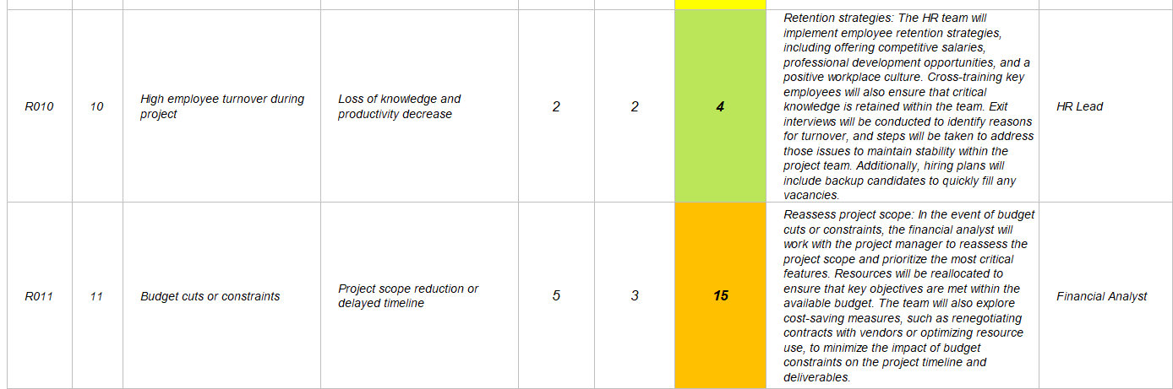

## **Task 5.2** **Pr**obability & Impact Rationale

Effective communication is pivotal to the success of Cipher Protocol. The company will implement clear communication channels and protocols to ensure all team members remain informed and aligned. Regular meetings, reports, and feedback sessions will facilitate the timely exchange of information, helping to identify and address issues swiftly (Kerzner, 2017). Open communication with players and stakeholders will also build trust and foster a supportive community around the game (Meredith etal., 2017).

**Risk 01: Changing Player Preferences**

**Probability (4):** High, due to the rapid evolution of gaming trends and shifting player expectations.

**Impact (3)**: Medium, as features misaligned with player preferences may lead to decreased engagement.

**Rationale:** Research shows that over 60% of games failing to adapt to market trends experience a drop in engagement (Gaming Insights, 2023). Continuous market analysis is critical to staying aligned with player needs.

**Response:** To mitigate this, Cipher Protocol will conduct regular player surveys and monitor community feedback to ensure the game's content evolves in line with player preferences. Additionally, real-time analytics will track player behavior to identify trends and adjust the game accordingly.

**While Cipher Protocol faces competition in the cyberpunk and stealth genres**, its unique combination of high-fidelity graphics, intricate narrative, and dynamic level design differentiates it. The game’s emphasis on vertical exploration and real-time decision-making provides a fresh perspective that appeals to players seeking a deeper, more immersive experience. Regular competitive analysis, coupled with feedback-driven improvements, will help the game stay ahead.

**Risk 02: System Crashes During Peak Periods**

**Probability (4):** High, due to expected traffic surges during launch and major events.

**Impact (5):** Very high, as crashes can result in negative reviews and loss of trust.

**Rationale:** Over 75% of online games experience server issues at launch (Tech Game Reviews, 2022), which can severely impact reputation and long-term player retention.

**Response:** The development team will implement robust server infrastructure with auto-scaling capabilities to handle traffic spikes. Stress tests will be conducted well before launch, and a dedicated IT support team will be on standby during peak periods to ensure any crashes are quickly addressed (Schwalbe, 2020).

**Risk 03: Inadequate User Training**

**Probability (3)**: Medium, if training programs are insufficient.

**Impact (3):** Medium, leading to inefficiencies and increased errors.

**Rationale:** Inadequate training accounts for 45% of user complaints (User Experience Journal, 2023). Proper training is crucial to enhancing productivity.

**Response:** Cipher Protocol will implement a comprehensive training program for both internal team members and users, including tutorials, documentation, and guided walkthroughs. Feedback from training sessions will be used to continuously refine and improve the program (Pressman & Maxim, 2020).

**Cipher Protocol will be developed using Unreal Engine 5,** chosen for its powerful rendering capabilities and open-world support. The development cycle is planned for 24 months, covering concept design, prototype development, production, and final optimization/testing. A core team of 50 developers will adopt an agile approach, with bi-weekly iterations and reviews to ensure quality and progress. In addition to Unreal Engine 5, the toolchain includes Maya for 3D modeling, Substance Painter for texturing, and proprietary level editing software to support dynamic level generation. Audio production will use Wwise middleware for complex audio systems, while performance optimization and bug fixes will be continuous. Closed beta testing will invite player feedback for final adjustments.**Response:**

**Risk 04: Regulatory Compliance Issues**

**Probability (2):** Low, due to proactive legal counsel.

**Impact (5):** Very high, with potential legal penalties and delays.

**Rationale:** Non-compliance can result in significant penalties, with 40% of projects delayed due to regulatory issues (Compliance Weekly, 2023).

**Response:** To mitigate this, Cipher Protocol will maintain continuous collaboration with legal experts to ensure compliance with all relevant regulations. The company will also regularly review new legislation and adjust development plans as necessary to avoid potential legal complications.(Meredith et al., 2017).

**Cipher Protocol's sales strategy involves a combination of digital and physical distribution channels.** The game will be available on major gaming platforms, including Steam, PlayStation, and Xbox, as well as through the company's website. Marketing efforts will include teaser trailers, developer diaries, and interactive content to build anticipation and engage the community. Postlaunch, the focus will shift to maintaining player interest through regular updates, community events, and feedback-driven improvements.

**Risk 05: Inadequate Data Security**

**Probability (4):** High, given the growing threat of cyberattacks.

**Impact (5):** Very high, with risks of data breaches and legal ramifications.

**Rationale:** 75% of game developers face data breaches during development (Data Security Monthly, 2023). Security is critical to protecting user data and company reputation.

**Response:** The company will implement rigorous security protocols, including encryption and multi-factor authentication, to protect both user data and internal systems. Regular security audits and penetration testing will be conducted to identify and address vulnerabilities.

**Risk 06: Hardware Procurement Delays**

**Probability (3):** Medium, due to global supply chain disruptions.

**Impact (3):** Medium, potentially delaying development timelines.

**Rationale:** 30% of game development projects experience delays due to hardware procurement issues (Hardware Procurement Insights, 2022).

**Response:** To mitigate the risk of delays, the company will establish relationships with multiple suppliers to ensure flexibility and have backup hardware procurement plans in place.

**Additionally, early procurement will be prioritized for critical hardware components.**

The revenue model for Cipher Protocol includes game sales, downloadable content, and potential merchandising opportunities. With high replay value and planned content updates, the game is expected to sustain player engagement and generate ongoing revenue. Additionally, multimedia licensing deals for comics or animated series could expand the game’s universe and attract new audiences.

**Risk 07: Supplier Failure to Deliver on Time**

**Probability (3):** Medium, due to reliance on third-party suppliers.

**Impact (4):** High, with potential project delays and cost increases.

**Rationale:** 25% of projects are delayed due to supplier issues (External Vendor Review, 2022).

**Response:** To address this, Cipher Protocol will implement strict performance monitoring for suppliers and maintain a buffer in the timeline to accommodate any delays. Contracts will include penalties for late deliveries to incentivize suppliers to meet deadlines.

**Risk 08: Poor Communication with Stakeholders**

**Probability (3):** Medium, if communication channels are not properly managed.

**Impact (3):** Medium, potentially causing misaligned expectations.

**Rationale:** 35% of project delays are attributed to poor communication with stakeholders (Project Management Weekly, 2023).

**Response:** Regular stakeholder meetings and clear communication plans will be established, ensuring that all parties are kept up to date on project progress. Dedicated points of contact will facilitate communication between different departments and stakeholders.

**Risk 09: System Integration Issues**

**Probability (4):** High, due to the complexity of integrating multiple systems.

**Impact (4):** High, as integration problems may lead to significant delays.

**Rationale:** 40% of system integrations face unexpected issues (Game Tech Journal, 2023).

**Response:** To mitigate this risk, regular integration testing will be performed throughout the development process. A specialized team will be tasked with overseeing the integration of different systems and identifying potential conflicts early.

**Long-Term Risk Mitigation Game development risks include technical challenges, market** competition, and evolving player preferences. To mitigate these risks, Cipher Protocol will adopt a flexible development approach, continuously gathering player feedback and iterating on the game’s content. Regular updates, partnerships with industry experts, and community engagement will ensure the game remains relevant, competitive, and aligned with market demands.

Financial Risk Response To safeguard the financial stability of the Cipher Protocol project, we have developed the following strategies:

**Risk 10: High Employee Turnover During the Project**

**Probability (4):** High, due to fierce competition for talent in the technology industry.

**Impact (4):** High, as the loss of key personnel could cause project delays and reduce productivity.

**Rationale:** Studies show that 20% of projects are delayed due to the departure of key team members (HR Tech Quarterly, 2023). Given the competitive nature of the technology industry, retaining talent is essential to maintaining project momentum.

**Response:** To mitigate this risk, Cipher Protocol will offer competitive salary packages, including performance bonuses and equity incentives, to attract and retain top talent. The company will also implement clear career development paths to ensure team members see growth opportunities within the project, reducing the likelihood of turnover.

**Risk 11: Budget Cuts or Restrictions**

**Probability (3):** Medium, due to potential economic fluctuations.

**Impact (5):** Very high, as budget cuts may severely impact the project scope, timeline, and overall quality.

**Rationale:** Financial constraints can lead to significant project delays or reductions in scope. 30% of development projects are adversely affected by budget constraints, leading to compromised quality (Finance Management Weekly, 2023).

**Response:** To mitigate this risk, Cipher Protocol will implement strict budget monitoring and develop contingency plans that prioritize essential features. In addition, the project will explore phased financing options to maintain steady cash flow throughout the development cycle, ensuring critical resources are always available.

**Sales and Marketing Strategy Cipher Protocol's sales strategy involves a combination of digital and physical distribution channels.** The game will be available on major gaming platforms, including Steam, PlayStation, and Xbox, as well as through the company's website. Marketing efforts will include teaser trailers, developer diaries, and interactive content to build anticipation and engage the community. Post-launch, efforts will shift toward maintaining player interest through regular updates, community events, and feedback-driven

Team Risk Response Maintaining a stable and efficient development team is crucial to the success of Cipher Protocol. The following strategies have been developed to address potential team risks:

**Identifying and Addressing Risks**

**1Cost Overrun Risk:**

**(1)Risk**: Development costs may exceed the budget.

**(2)Countermeasures:** Implement strict cost control, with regular budget reviews and an early warning system for potential overruns.

**2.Cash Flow Risk:**

**(1)Risk:** Long development cycles could lead to cash flow pressure.

**(2)Countermeasures:** Develop a detailed cash flow forecast, ensuring sufficient reserves, and consider phased financing to introduce funds at critical points.

**3.Exchange Rate Risk**:

**(1)Risk**: International sales may face exchange rate fluctuations.

**(2)Countermeasures:** Use financial instruments like forward contracts to hedge risks and consider local subsidiaries in key markets.

**4.Investment Return Risk:**

**(1)Risk:** Lower-than-expected sales could affect returns.

**(2)Countermeasures:** Develop financial models for different scenarios and adopt a phased investment strategy to adjust based on progress and feedback.

**5.Intellectual Property Risk:**

**(1)Risk:** Possible disputes over intellectual property.

**(2)Countermeasures:** Conduct thorough IP due diligence and seek patent protection for core technologies, with a legal dispute fund reserved.

**The strategy for Cipher Protocol involves establishing a strong presence in the cyberpunk genre through high-quality content and continuous updates.** This includes leveraging the game's unique features to attract and retain players, expanding the game's universe through multimedia adaptations, and building a strong community around the game. Long-term plans focus on creating a sustainable revenue model through game sales, downloadable content, and potential merchandising opportunities.

**6.Talent Loss Risk**

**(1)Risk:** Core team members may be poached by competitors.

**(2)Countermeasures:** In addition to offering competitive compensation, Cipher Protocol will foster a strong company culture that emphasizes teamwork, innovation, and employee well-being. Regular performance reviews and career development opportunities will keep team members engaged and aligned with the company’s long-term vision.

**7.Team Collaboration Risk**

**(1)Risk:** Communication barriers may occur during cross-departmental collaboration, leading to inefficiencies and project misalignments.

**(2)Countermeasures:** Cipher Protocol will adopt a flat management structure to encourage open communication between departments. Regular cross-departmental meetings and the use of project management tools will promote information sharing and streamline collaboration across the development team.

**8.Risk of Skills Shortage**

**(1)Risk:** Some key skills may be lacking, which could delay development or lower product quality.

**(2)Countermeasures:** Cipher Protocol will conduct regular skills assessments to identify potential gaps in expertise. Continuous training opportunities will be provided, and external experts may be brought in when necessary. If required, outsourcing specific tasks will also be considered to address any immediate skill shortages.

**9.Risk of Team Burnout**

**(1)Risk:** High-intensity work environments may lead to team fatigue, reducing productivity and increasing turnover.

**(2)Countermeasures:** The company will implement a reasonable work-time policy, limiting excessive overtime and providing flexible working hours. Team members will have access to stress management resources, and regular health check-ins will ensure the well-being of the workforce.

**10.Risk of Cultural Conflict**

**(1)Risk:** As the team grows and becomes more diverse, cultural integration issues may arise, leading to misunderstandings or conflict.

**(2)Countermeasures:** The company will clearly define and communicate its cultural values, ensuring all team members share the same core principles. During recruitment, cultural fit will be considered, and regular team-building activities will be organized to strengthen team cohesion.

## 

## Task 5.3 The Matrix & Analysis

|  |  |  |  |  |  |  |
| --- | --- | --- | --- | --- | --- | --- |
| P R O B A B I L I T Y | 5 |  |  | R02 |  | R01 |
| 4 |  |  | R03 | R06 | R05 |
| 3 |  |  | R08 | R07 | R011 |
| 2 |  | R010 | R09 |  | R04 |
| 1 |  |  |  |  |  |
|  |  | 1 | 2 | 3 | 4 | 5 |
|  |  | I M P A C T | | | | |

**The probability/impact matrix is essential for identifying, visualizing, and analyzing risks in the Cipher Protocol project.** By assessing both the likelihood (probability) and severity (impact) of each risk, the matrix offers an effective decision-making framework for resource allocation and mitigation strategies (Kerzner, 2017). Below, I explain how the matrix supports better risk management, prioritization, and alignment with the company’s strategic objectives.

**Business Case: Company Background and Strategic Goals**

Cipher Protocol is an innovative game development company focused on creating immersive experiences in the cyberpunk genre. The company’s strategic goals include delivering engaging, narrative-driven games while maintaining a competitive edge in a rapidly evolving market. This project focuses on delivering a new storyline expansion, aligning with the company’s objectives to expand its player base and increase engagement through rich storytelling and interactive features.(Meredith et al., 2017).

The value delivered by the Cipher Protocol: Shadow Nexus project is directly tied to these objectives, as it introduces key narrative features and enhanced gameplay elements, such as the deep hacking system. The integration of these features reflects the company’s commitment to offering cutting-edge gameplay, which aligns with its strategic priorities.

**Resource Allocation and Priority Setting**

The probability/impact matrix visualizes risks that may affect the project’s success and where resources should be concentrated.

**Based on the matrix, risks are categorized as high, medium, or low priority depending on their probability and impact.**

**(1)High-Priority Risks (Upper-right corner of the matrix):**

R02 (System Crash During Peak Hours): This risk has both high probability and impact, emphasizing the importance of allocating resources toward scalable server infrastructure and stress testing.

R01 (Changing Player Preferences): High impact and probability make this a critical risk that requires regular community feedback and adaptability in content updates to meet evolving player expectations.

Resource Implications: Resources should be concentrated on system stability (R02) and player engagement strategies (R01) to mitigate these high-priority risks and ensure long-term success. These are aligned with the company’s goal of delivering a smooth and engaging player experience.

**(2)Medium-Priority Risks:**

R05 (Inadequate Data Security): Moderate probability and high impact suggest that cybersecurity should remain a focus, but at a secondary level compared to R01 and R02. Regular security audits are necessary.

R07 (Supplier Failure to Deliver on Time) and R06 (Hardware Procurement Delays): Both of

these risks involve supply chain issues, which could delay the project but are unlikely to cause significant disruptions if managed proactively. Establishing strong supplier relationships and diversifying hardware procurement sources will mitigate these risks.

Resource Implications: Resources for these medium-priority risks should be allocated to cybersecurity and supplier management, but they do not require the same urgency as high-priority risks.

**(3)Low-Priority Risks:**

R03 (Inadequate User Training) and R04 (Regulatory Compliance Issues): These risks have lower probability and impact but should be monitored to ensure they do not escalate.

R10 (High Employee Turnover) and R09 (System Integration Issues): These risks should be

mitigated through employee retention strategies and early testing for system integration issues.

Resource Implications: These risks require fewer resources but must still be monitored. Action should be taken only if there are signs of escalation.

Decision-Making Insights from the Matrix

The matrix enables the project management team to prioritize risks based on both likelihood and severity. This structured approach helps in:

Prioritizing risk responses: High-priority risks, such as system crashes and changing player preferences, should be addressed first.

Allocating resources efficiently: By concentrating on high-priority risks, the project team can allocate resources where they will have the most impact.

Developing risk mitigation plans: For high-priority risks, detailed mitigation strategies must be developed. Medium and low-priority risks can be addressed with ongoing monitoring and contingency planning(Kerzner, 2017)..

**Risk Response Strategy**

**(1)High-Priority Risks:**

R02 (System Crash During Peak Hours): Build a scalable server infrastructure, conduct rigorous stress tests before launch, and assign a dedicated IT team to monitor system performance during key events.

R01 (Changing Player Preferences): Leverage community feedback and market research to continuously update and refine the game's content. Regular player engagement will ensure the game remains aligned with market trends and user preferences.

**(2)Medium-Priority Risks:**

R05 (Inadequate Data Security): Implement ongoing security audits and vulnerability assessments. Invest in cybersecurity tools that address potential data breaches.

R07 (Supplier Failure to Deliver on Time): Strengthen supplier agreements by including clear deadlines and penalties for delays. Establish alternative suppliers to reduce dependency on a single source.

**(3)Low-Priority Risks:**

R03 (Inadequate User Training): Provide a comprehensive training program with video tutorials, but escalate resources only if user feedback indicates significant issues.

R10 (High Employee Turnover): Implement competitive employee benefits and provide growth opportunities to retain key talent.

**Communication and Continuous Monitoring**

The matrix not only aids in resource allocation but also in effective communication with stakeholders. High-priority risks should be communicated clearly to ensure that all team members are aligned and contribute to the mitigation efforts. Key actions include:

Regularly updating the risk register and matrix to reflect changes in the project's risk profile.

Ensuring that stakeholders are aware of mitigation strategies for high-priority risks.

Engaging stakeholders in discussions about medium-priority risks to determine if escalation is necessary.

**Conclusion**

By identifying, analyzing, and prioritizing risks using the probability/impact matrix, the Cipher Protocol: Shadow Nexus project team can effectively allocate resources, focus on critical areas, and ensure the project’s success. This structured approach provides a clear path forward and ensures that risks are managed proactively, thus aligning with the company’s strategic goals of delivering a high-quality gaming experience.

# DELIVERABLE 6: Project Quality Management

**6.1 Defining Quality for the Cipher Protocol Project:**

Quality in the Cipher Protocol project is defined in terms of system performance, user satisfaction, and compliance with regulatory standards. It is measured through specific, quantifiable criteria critical to success, including user experience, system stability, cybersecurity, and compliance (Kerzner,2017).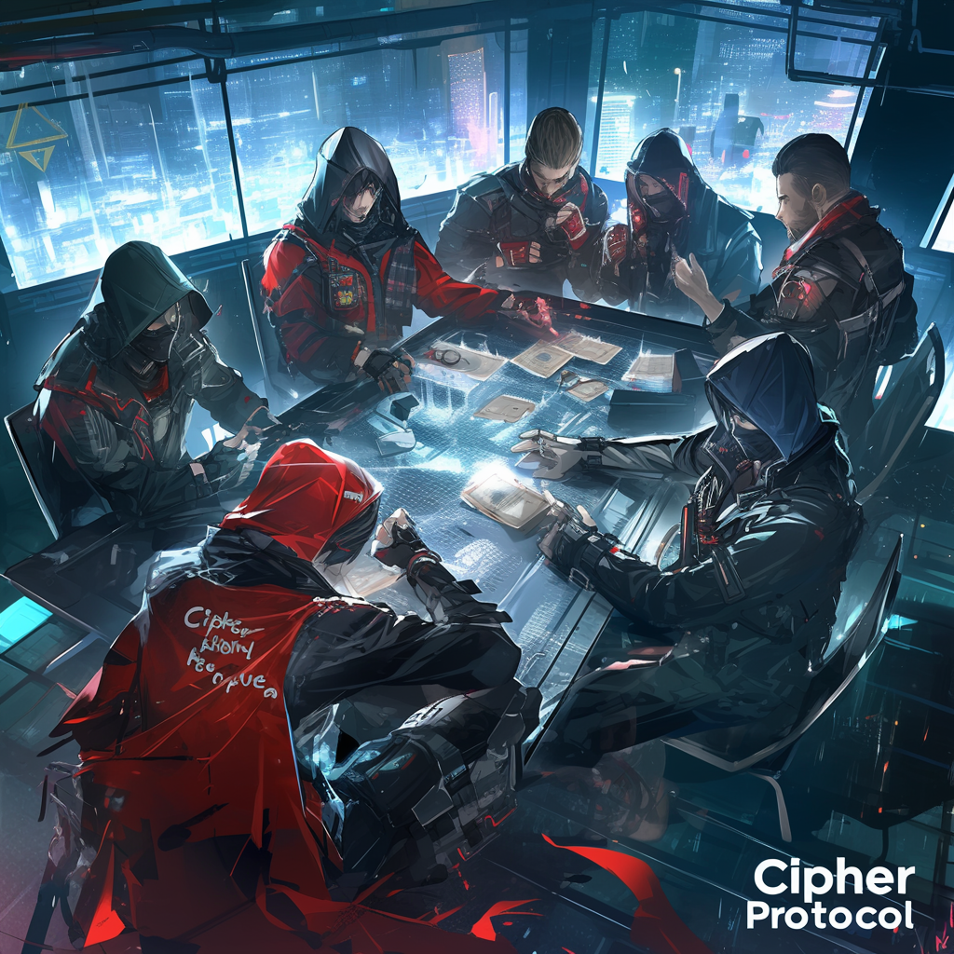

**Key Quality Standards**

**1.System Performance and Stability:**

**(1)Standard:** The game should have no more than one unplanned downtime incident per 30 days during the beta testing phase. System uptime should be maintained at 99.9% or higher during all major events.

**(2)Rationale:** High system stability is essential during peak periods to maintain user trust and engagement. Maintaining an uptime of 99.9% ensures that system crashes and other interruptions are minimized, keeping the player experience uninterrupted (Pressman & Maxim, 2020).

**2.User Experience (UX) Satisfaction:**

**(1)Standard:** At least 95% of users during beta testing should rate the game’s navigation and interface as "easy" or "very easy" on a post-test survey.

**(2)Rationale**: A seamless and intuitive user experience is critical to player engagement and satisfaction. The 95% threshold ensures that the majority of players can navigate the game without difficulty, which is a key factor in retaining users and reducing churn (Schwalbe, 2020).

**3.Loading Times:**

**(1)Standard:** Game loading times should not exceed 3 seconds on average for major screens, with a maximum of 5 seconds during peak periods.

**(2)Rationale:** Fast loading times contribute to a smooth user experience, especially during transitions between gameplay areas. A load time of 3-5 seconds ensures minimal disruption, keeping players immersed in the game (Kerzner, 2017).

**4.Cybersecurity and Data Protection:**

**(1)Standard:** The system must undergo quarterly penetration testing and maintain zero breaches of player data. All player data should be encrypted using AES-256 encryption.

**(2)Rationale:** Data security is paramount to maintaining player trust and compliance with global data protection laws (e.g., GDPR). Regular penetration testing ensures that the game’s cybersecurity defenses remain robust, while encryption prevents unauthorized access to sensitive information (Pressman & Maxim, 2020).

**5.Compliance with Industry Regulations:**

**(1)Standard:** The game must comply with ESRB and PEGI ratings, ensuring that the content is properly classified for its intended audience. The game must pass all certification tests before its release to global markets.

**(2)Rationale**: Regulatory compliance is essential to launch the game successfully across different regions. Failing to meet these standards could result in delays or legal challenges (Kerzner, 2017).

**6.Plan to Achieve Quality**

To ensure that the above quality standards are met, the following actions will be taken:

**(1)User Testing and Feedback:**

**Action:** Conduct multiple rounds of user testing during alpha and beta stages, focusing on key metrics like user satisfaction (navigation, ease of use) and system performance (load times, stability).

**Measurement:** Surveys and direct feedback from beta testers, with at least 95% rating the system’s navigation as “easy” or “very easy.” Any areas falling below this threshold will undergo immediate revisions, with feedback incorporated into future iterations (Schwalbe, 2020).

**(2)System Performance Monitoring:**

**Action:** Implement real-time monitoring tools (such as New Relic or Datadog) to track system uptime, detect performance bottlenecks, and ensure that uptime remains at 99.9% during testing phases and major events.

**Measurement:** Regular reports on system performance will be generated, highlighting any downtimes or system crashes. A troubleshooting team will be on standby to address critical issues within 30 minutes of detection (Kerzner, 2017).

**(3).Continuous Integration and Deployment (CI/CD):**

**Action:** Utilize a CI/CD pipeline to automate build and test processes, ensuring that new code does not introduce bugs or system performance issues.

**Measurement:** The pipeline will include automated unit tests and integration tests for every build, with a target of 85% test coverage. This ensures code quality and reduces errors that could impact performance (Pressman & Maxim, 2020).

**(4).Penetration Testing and Security Audits:**

**Action**: Schedule quarterly penetration tests conducted by third-party cybersecurity experts to identify potential vulnerabilities. Implement AES-256 encryption for all sensitive player data.

**Measurement:** After each penetration test, a report will be generated with identified vulnerabilities and resolutions. The goal is to maintain zero data breaches throughout the testing and post-launch phases (Schwalbe, 2020).

**(5).Compliance Audits:**

**Action:** Ensure that the game’s content is reviewed and classified in accordance with ESRB and PEGI guidelines. The game will undergo formal audits to ensure it meets the necessary regulatory standards.

**Measurement:** Certification must be achieved before launch, with all content modifications completed as per regulatory requirements. The game cannot be released without meeting these standards (Kerzner, 2017).

**7.Why These Standards?**

The selected standards (99.9% uptime, 95% user satisfaction, 3-5 second load times, zero breaches, and regulatory compliance) are aligned with the project's objectives of delivering a stable, user-friendly, and secure gaming experience. These metrics ensure that critical aspects of the game (performance, user experience, security) are not only addressed but quantifiably measured to meet stakeholder and player expectations (Pressman & Maxim, 2020).

**95% User Satisfaction** is selected based on industry benchmarks for game usability. Games with intuitive interfaces and minimal friction tend to retain users better, which is crucial in maintaining a loyal player base.

**99.9% Uptime** is chosen because any significant downtime can directly impact player experience, leading to negative reviews and reduced trust.

**AES-256 Encryption** and zero breaches are necessary for data protection and to comply with global privacy regulations like GDPR.

These standards are right for Cipher Protocol because they ensure that the game meets high-quality expectations while safeguarding the company’s reputation and reducing risk.

## Task 6.2 Metrics and Measurement

To ensure that **Cipher Protocol**: **Shadow Nexus** meets its quality standards, we have strategically selected metrics and progress measures that align with recognized industry benchmarks. These metrics will allow for continuous monitoring and improvements, ensuring that the game maintains its high-quality standards throughout development and post-launch.



**Quality Criterion 1: Stable Frame Rate (60 FPS)**

**Requirement:**  
The game must run at a stable speed of at least 60 frames per second (FPS) on 95% of supported platforms under standard gaming conditions.

**Rationale:**  
Maintaining 60 FPS is essential to ensure a smooth, responsive gameplay experience, particularly in action-heavy and graphically complex games. This target is aligned with industry standards, where modern AAA games aim for 60 FPS or higher to meet player expectations and prevent performance issues like screen tearing and input lag.

**Metric:**

**Performance Monitoring**: FPS performance will be measured using performance tools such as NVIDIA FrameView or Fraps across alpha, beta, and post-release stages.

**Measurement Milestones**: FPS metrics will be gathered at critical stages, including:

Alpha testing

Beta testing

Final release

**Success Threshold:** At least 95% of tested devices across a range of performance capabilities must achieve 60 FPS.

**Measurement Process:**

Automated Testing: FPS performance will be continuously tracked through automated performance testing tools across multiple device categories (high-end, mid-range, low-end).

Regular Reports: Weekly performance reports will be generated, summarizing FPS consistency across platforms and identifying devices that fail to meet the target.

Optimization Cycles: Devices failing to achieve 60 FPS will undergo targeted optimization to boost performance.

**Reference to Industry Standards:**  
The 60 FPS benchmark is an industry-recognized standard for AAA games, particularly in fast-paced action games. Maintaining this performance level ensures smoother animations and reduced input latency, in line with industry best practices.

**Quality Criterion 2: Secure User Data Encryption**

**Requirement:**  
At least 99% of user data must be securely encrypted during transmission and storage to prevent unauthorized access.

**Rationale:**  
Data security is paramount in today’s gaming industry, especially with global privacy regulations such as the General Data Protection Regulation (GDPR) and the California Consumer Privacy Act (CCPA). These laws require the encryption of personal and sensitive information. Maintaining high data encryption standards is critical for player trust and legal compliance.

**Metric:**

**Data Encryption Audit:** Regular encryption audits will verify that 99% of user data is protected using AES-256 encryption for storage and SSL/TLS protocols during transmission.

**Audit Frequency:** Audits will be conducted quarterly during development and post-launch.

**Success Threshold:** A minimum of 99% of all user data must be encrypted according to industry standards.

**Measurement Process:**

**Quarterly Encryption Audits:** Data encryption protocols will be reviewed by third-party auditors using tools such as Splunk and Wireshark to ensure data is encrypted during transmission and storage.

**Real-Time Monitoring:** Automated monitoring will ensure data encryption is active throughout all user interactions with the game, preventing unencrypted data from being exposed.

**Audit Reports:** Reports will be reviewed, and any areas falling below the 99% threshold will be immediately addressed by the security team.

**Reference to Industry Standards:**  
AES-256 encryption and SSL/TLS protocols are the recognized industry standards for securing data in modern digital services, ensuring compliance with regulations like GDPR and CCPA. Achieving 99% encryption ensures the highest levels of data security without negatively impacting performance.

**Quality Criterion 3: Stability During Peak Usage (Crash-Free Rate)**

**Requirement:**  
During peak usage periods (e.g., launch days, special events, or DLC releases), the game must achieve a 99.5% crash-free rate.

**Rationale:**  
Stability during high-traffic periods is a critical industry benchmark for successful game launches. High crash rates can damage player trust, lead to negative reviews, and result in player churn. 99.5% crash-free performance is in line with industry expectations for high-traffic events.

**Metric:**

**Crash-Free Rate Monitoring:** The crash-free rate will be tracked in real-time using tools such as Crashlytics and New Relic during all high-traffic events (launch, major DLC releases).

**Success Threshold:** At least 99.5% of sessions during peak periods must be crash-free.

Post-Event Reporting: Crash logs will be reviewed after each event to confirm the crash-free rate.

**Measurement Process:**

**Real-Time Monitoring:** Tools like Crashlytics will be used to track crash-free sessions in real-time, particularly during peak events such as launch and DLC releases.

**Stress Testing:** Prior to each major event, stress tests will be conducted to simulate high user loads and identify potential bottlenecks or stability issues.

**Post-Event Reports:** After each event, performance data will be compiled into reports, which will be reviewed by the development team to ensure compliance with the 99.5% standard.

**Reference to Industry Standards:**  
Achieving a 99.5% crash-free rate during peak periods is consistent with industry benchmarks for high-traffic stability, particularly for games with large-scale online multiplayer environments. This standard ensures that the game can handle spikes in traffic without compromising the player experience.

**Quality Criterion 4: User Satisfaction with Navigation and Interface**

**Requirement:**  
At least 95% of beta testers should rate the game’s navigation and interface as "easy" or "very easy" on a post-test survey.

**Rationale:**  
User satisfaction is critical for both player retention and game success. The 95% satisfaction rate is based on industry surveys where ease of navigation significantly impacts user retention. Achieving this level of satisfaction indicates that the user experience is intuitive and enjoyable.

**Metric:**

User Satisfaction Survey: Surveys will be distributed after each beta testing phase to measure satisfaction with the game’s interface and navigation.

Threshold for Success: At least 95% of survey respondents must rate the game’s navigation as "easy" or "very easy."

In-Depth Follow-Up: Any ratings below 95% will be addressed through follow-up interviews to identify pain points.

**Measurement Process:**

**Survey Distribution:** Post-beta surveys will be conducted via email or in-game prompts, asking users to rate the ease of navigation on a 5-point Likert scale.

Data Analysis: Survey results will be analyzed to calculate the percentage of users rating the navigation as "easy" or "very easy." Results falling below 95% will prompt a deeper analysis of user feedback.

Follow-Up Interviews: Follow-up interviews will be conducted for testers who rated the navigation lower than expected to gather actionable insights for improvement.

**Reference to Industry Standards:**  
User experience standards in the gaming industry emphasize intuitive and accessible navigation, with a 95% satisfaction rate commonly seen in high-quality, well-received games. This metric ensures that the game delivers a smooth and engaging user experience.

**Quality Criterion 5: Loading Time Optimization**

**Requirement:**  
The game’s loading times should not exceed 3 seconds on average during normal conditions, with a maximum of 5 seconds during peak periods.

**Rationale:**  
Loading times are a significant factor in player satisfaction. Studies show that players are more likely to abandon or negatively rate games with long loading times. An average load time of 3 seconds is considered a best practice in the industry, with a 5-second maximum during peak periods being an acceptable buffer for increased server load.

**Metric:**

**Loading Time Measurement:** Load times will be monitored using automated testing tools during all phases of development and post-launch.

**Success Threshold:** Average load times must not exceed 3 seconds during regular play and 5 seconds during peak periods.

**Stress Testing:** Before peak periods, stress tests will be conducted to ensure load times remain within the acceptable range.

**Measurement Process:**

**1.Automated Load Testing:** Tools such as Selenium and in-house performance trackers will measure load times across different devices and network conditions.

**2.Peak Period Monitoring:** Load times during key peak periods (e.g., launch day, DLC releases) will be recorded and analyzed to ensure they do not exceed the 5-second maximum.

**3.Optimization Cycles:** If load times exceed acceptable limits, the game will undergo performance optimization to streamline asset loading and reduce server-side delays.

**Reference to Industry Standards:**  
Maintaining average load times of 3 seconds or less aligns with player expectations in AAA games, where rapid loading times contribute to an uninterrupted and immersive gaming experience.

# DELIVERABLE 7: Project Stakeholder and Communication Management

## Task 7.1 Building Your Stakeholder Register

At Cipher Protocol, we are committed to delivering deep, innovative, and memorable gaming experiences. Our core philosophy revolves around four pillars:

1. **Player-Centric Design:** We prioritize the player experience in every development decision, ensuring our games are engaging, fun, and immersive (Schwalbe, 2020).
2. **Innovation**: We strive to push the boundaries of game design, narrative, and technology, encouraging bold new ideas from our team (Kerzner, 2017).
3. **Artistic Expression:** We view games as a form of art and incorporate profound themes into gameplay, aiming to resonate with players on an emotional and intellectual level (Pressman & Maxim, 2020).
4. **Team Collaboration:** Through teamwork and open communication across departments, we ensure the seamless realization of our creative vision (Project Management Institute, 2021).

These values are reflected in our project management approach, where strong stakeholder relationships and effective communication are paramount.

**The Stakeholder Register i**s a structured method to identify, analyze, and manage stakeholders throughout the project lifecycle. Understanding the power and interest levels of each stakeholder is crucial to determining how best to communicate with them, ensuring project success (Bourne, 2016).

**Below is the stakeholder register for Cipher Protocol: Shadow Nexus,** detailing the key stakeholders, their roles, and the appropriate communication strategies.



|  |  |  |  |  |  |  |  |  |  |
| --- | --- | --- | --- | --- | --- | --- | --- | --- | --- |
| **NO** | **Name** | **TITLE** | **ROLE IN PROJECT** | **CATEGORY** | **POWER LEVEL** | **INTEREST LEVEL** | **COMMS REQUIREMENTS** | **COMMS FREQUENCY** | **CONTACT** |
| 1 | Ziqi Pei | Project Manager | Project Manager | External | High | High | Team meetings, decision-making | As required | zpei0003@student.monash.edu |
| 2 | Xiaoyao Li | Software Developer | Software Developer | Internal | Medium | High | Technical discussions, team meetings | Weekly | xli0001@student.monash.edu |
| 3 | James Chen | Tester | Tester | External | Medium | Medium | Weekly test updates, reports | Weekly | jchen0002@student.monash.edu |
| 4 | Cobie Lex | UI/UX Designer | UI/UX Designer | Internal | Medium | Medium | Design review meetings | Weekly | ewong0003@student.monash.edu |
| 5 | Emily Wong | Security Architect | Security Architect | External | High | High | Security audit reports, review | Bi-weekly | asmith0004@student.monash.edu |
| 6 | Alex Smith | Business Analyst | Business Analyst | Internal | Medium | High | Stakeholder requirement sessions | Monthly | asmith0004@student.monash.edu |
| 7 | Xiaofan Liu | Executive Sponsor | Executive Sponsor | External | High | Medium | Project oversight and final approval | Monthly | xliu0005@student.monash.edu |
| 8 | YuCheng Shi | Client Representative | Client Representative | External | High | High | Review meetings, feedback sessions | Monthly | yshi0006@student.monash.edu |
| 9 | Sarah Johnson | Marketing Specialist | Marketing Specialist | Internal | Medium | Medium | Marketing campaign updates | Bi-weekly | sjohnson0007@student.monash.edu |
| 10 | Michael Zhang | IT Support | IT Support | Internal | Low | Low | On-demand technical support | As needed | mzhang0008@student.monash.edu |
| 11 | Lisa Brown | Legal Advisor | Legal Compliance | External | Medium | High | Legal reviews, compliance reports | As required | lbrown0009@student.monash.edu |
| 12 | Elon Musk | Producer | Project Oversight | Internal | High | High | Progress reports, resource allocation | Weekly | elonmusk@spex.com |

**Power/Interest Grid Analysis**

Stakeholders can be categorized based on their level of power (ability to influence the project) and interest (level of concern or involvement in project outcomes) (Bourne, 2016). This categorization helps prioritize communication efforts and ensure expectations are managed appropriately:

**1.High Power - High Interest (Key Decision Makers):**

Ziqi Pei (Project Manager), Emily Wong (Security Architect), YuCheng Shi (Client Representative)

Management Strategy: These stakeholders have a direct influence on project success. Their expectations must be actively managed through regular meetings and close involvement in decision-making.

**2.High Power - Low Interest (Keep Satisfied):**

Xiaofan Liu (Executive Sponsor)

Management Strategy: Keep these stakeholders informed through high-level project status updates. While their direct involvement may be minimal, ensuring they are satisfied prevents unexpected disruptions.

**3.Low Power - High Interest (Keep Informed):**

Alex Smith (Business Analyst), Cobie Lex (UI/UX Designer), James Chen (Tester)

Management Strategy: Regular communication is required to keep these stakeholders adequately informed and engaged. Their expertise can significantly contribute to the project's success.

**4.Low Power - Low Interest (Monitor):**

Michael Zhang (IT Support)

Management Strategy: These stakeholders should be monitored and only involved as needed. Excessive communication may not be necessary unless issues arise.

**Organizational Structure**

The development team at Cipher Protocol operates under a flat organizational structure that encourages creativity, fast decision-making, and cross-departmental collaboration (Schwalbe, 2020). Key departments and their responsibilities include:

**1.Creative Department:** Responsible for the overall vision, plot design, and gameplay mechanics. Led by the Creative Director.

**2.Technical Department:** Focused on game engine development, toolchain creation, and technical support. Led by the Technical Director.

**3.Art Department:** Oversees visual style, character and environment design. Led by the Art Director.

**4.Audio Department:** Handles music, sound effects, and voiceovers. Led by the Audio Director.

**5.Production Department:** Manages project timelines, resources, and budgets. Led by the Producer.

**6.QA Department:** Ensures game quality through rigorous testing. Led by the QA Manager.

**Cross-Departmental Collaboration:**  
We hold regular cross-departmental meetings to ensure seamless communication and cooperation. Additionally, the Creative Committee, composed of key members from each department, meets regularly to review major design and development decisions, ensuring that the project remains aligned with the company's vision (Kerzner, 2017).

**Communication Plan**

A clear communication plan is essential to keep all stakeholders informed and engaged throughout the project lifecycle. The communication strategy for Cipher Protocol is based on the power/interest grid and tailored to the specific needs of each stakeholder group. The communication plan includes:

**Comms Requirements:** Tailored communication channels (email, phone calls, presentations) for each stakeholder.

**Comms Frequency:** Defined intervals for communication (e.g., daily, weekly, monthly) based on the stakeholder's power and interest levels.

By ensuring regular and structured communication, the project management team will keep stakeholders aligned with the project’s progress and address any concerns before they escalate.

## Task 7.2 Engagement Strategy

Engaging with key stakeholders is essential for the success of Cipher Protocol. To ensure the project meets its objectives and aligns with external requirements, it's important to have a targeted engagement strategy for high-power, high-interest stakeholders who are not directly on the project team (Bourne, 2016).

The following engagement strategies focus on two key stakeholders, Shiyu Chen (Main Client Liaison) and Xiaofan Liu (Executive Sponsor). Both hold significant influence over the project's success, and managing their expectations and communication efficiently is critical. Confidentiality will be maintained in all interactions with external stakeholders to protect proprietary information and ensure the integrity of the project (Pressman & Maxim, 2020).

**Stakeholder 1: Shiyu Chen (Main Client Liaison) - External Stakeholder**

**Stakeholder Profile:**

**Name and Role**: Shiyu Chen, Main Client Liaison

**Category:** External Stakeholder

Power and Interest Level: High power, high interest. Shiyu represents the client and has a direct influence on the project’s success through her feedback and approval.

**Influence and Impact:**

Influence on the Project: Shiyu’s feedback and decisions are essential in shaping the project’s scope and deliverables, especially regarding the client's specific requirements and expectations.

Impact of the Project on the Stakeholder: The successful completion of the project enhances Shiyu’s standing with her organization and strengthens the professional relationship between the client and Cipher Protocol.

**Engagement Objectives:**

**Goal:** Maintain Shiyu's support and ensure that client expectations are fully met throughout the project lifecycle.

**Stakeholder Needs and Expectations:**

**(1)Primary Concerns:** Alignment with client requirements, timely project delivery, and seamless integration with existing systems.

**(2)Success Criteria:** On-time project completion, delivery of high-quality products that meet or exceed client expectations, and ensuring the solution integrates effectively with client infrastructure.

**Communication Plan:**

(1.Weekly progress updates via secure email

(2).Bi-weekly status meetings (virtual or in-person)

(3)One-on-one meetings for critical issues or urgent matters

Messaging Strategy: Focus on project progress, address any concerns proactively, and reinforce a commitment to the client's success.

**Action Plan:**

(1).Schedule bi-weekly review meetings with Shiyu to provide updates on project progress, gather feedback, and ensure alignment with client expectations.

(2)Involve Shiyu in key decision-making moments, such as changes in project scope or priorities.

(3)Provide early demonstrations of prototypes or features to gather feedback and adjust the project if needed.

Responsibilities: The Project Manager will lead communication with Shiyu, ensuring that her feedback is properly integrated into project planning and execution.

**Monitoring and Feedback:**

**1Feedback Mechanisms:**

Solicit feedback during regular meetings and through periodic satisfaction surveys at key project milestones.

Encourage Shiyu to provide input on potential improvements or concerns early.

**2Adjustments:**

Adapt project strategies and communication based on Shiyu's feedback, making real-time adjustments to ensure client satisfaction.

**3Risk Management:**

**(1)Potential Risks:**

Misalignment between project deliverables and client expectations.

Delayed communication leading to unmet client needs.

**(2)Mitigation Strategies:**

Maintain clear and frequent communication with Shiyu, involving her in major decisions.

Validate client requirements regularly and confirm alignment at key project stages.

**(3)Confidentiality Considerations:**

Shiyu, being external, will receive only the necessary project details and updates. All communications will be protected under a confidentiality agreement, and sensitive data will be shared through secure channels (e.g., encrypted emails and secure video conferencing platforms).

**Stakeholder 2: Xiaofan Liu (Executive Sponsor) - Internal Stakeholder**

**Stakeholder Profile:**

**Name and Role:** Xiaofan Liu, Executive Sponsor

**Category:** Internal Stakeholder

Power and Interest Level: High power, medium interest. As the Executive Sponsor, Xiaofan has oversight of the project but may not be involved in day-to-day activities. He plays a key role in budget decisions and approving major project milestones.

**Influence and Impact:**

Influence on the Project: Xiaofan provides approval for project scope, budget, and deliverables. His influence is crucial for major project decisions and ensuring the project aligns with company objectives.

Impact of the Project on the Stakeholder: Successful completion of the project strengthens Xiaofan’s role in the organization, demonstrating his ability to sponsor successful initiatives and meet business goals.

**Engagement Objectives:**

**Goal:** Keep Xiaofan informed of key project milestones and ensure his approval for strategic decisions regarding budget, scope, and overall project alignment with company goals.

**Stakeholder Needs and Expectations:**

**Primary Concerns**: Ensuring the project stays on budget, aligns with the company’s strategic objectives, and delivers on time.

**Success Criteria:** The project meets strategic objectives, stays within the approved budget, and is completed according to schedule.

**Communication Plan:**

1.Monthly high-level project updates

2.Budget and scope approval meetings

3.Ad hoc check-ins for critical issues or high-level strategic adjustments

Messaging Strategy: Focus on strategic alignment and high-level deliverables, ensuring Xiaofan is kept informed about budget, scope, and major project risks.

**Action Plan:**

1.Provide monthly project updates to keep Xiaofan informed of key project milestones.

2.Involve Xiaofan in decision-making related to budget changes or significant project adjustments.

3.Present project updates at internal leadership meetings where Xiaofan can provide guidance and approvals.

**Responsibilities:**

The Project Manager will be responsible for providing regular updates to Xiaofan and ensuring that his input is reflected in the project’s strategic decisions.

**Monitoring and Feedback:**

Gather feedback from Xiaofan during monthly updates and ensure his concerns are addressed.

Provide opportunities for Xiaofan to review and approve key project changes and financial decisions.

**Adjustments:** Make project adjustments if Xiaofan identifies issues related to the budget, scope, or strategic alignment.

**Risk Management:**

(1)Lack of engagement from Xiaofan, leading to delayed approvals.

(2)Budget overruns due to misalignment on financial expectations.

(3)Delays in documentation from Ziqi’s side, affecting the project timeline.

**Mitigation Strategies:**

Frequent check-ins with Shiyu and Ziqi to ensure clear communication and timely feedback.

Ensuring that the project team has contingency plans in case of delays from Ziqi’s side.

**Confidentiality Considerations:**

As an internal stakeholder, Xiaofan will have access to strategic information about the project. However, sensitive data related to proprietary technologies or client-specific information will be shared selectively based on need and relevance to his role.

# Conclusion

Cipher Protocol represents an ambitious and innovative project within the cyberpunk action-stealth genre. By combining dynamic gameplay, ethical storytelling, and robust financial planning, the game is poised to achieve significant commercial success and critical acclaim (Schwalbe, 2020; Kerzner, 2017). The comprehensive business plan outlines a clear path to market, ensuring that Cipher Protocol will captivate players and set a new standard for immersive gaming experiences (Pressman & Maxim, 2020).

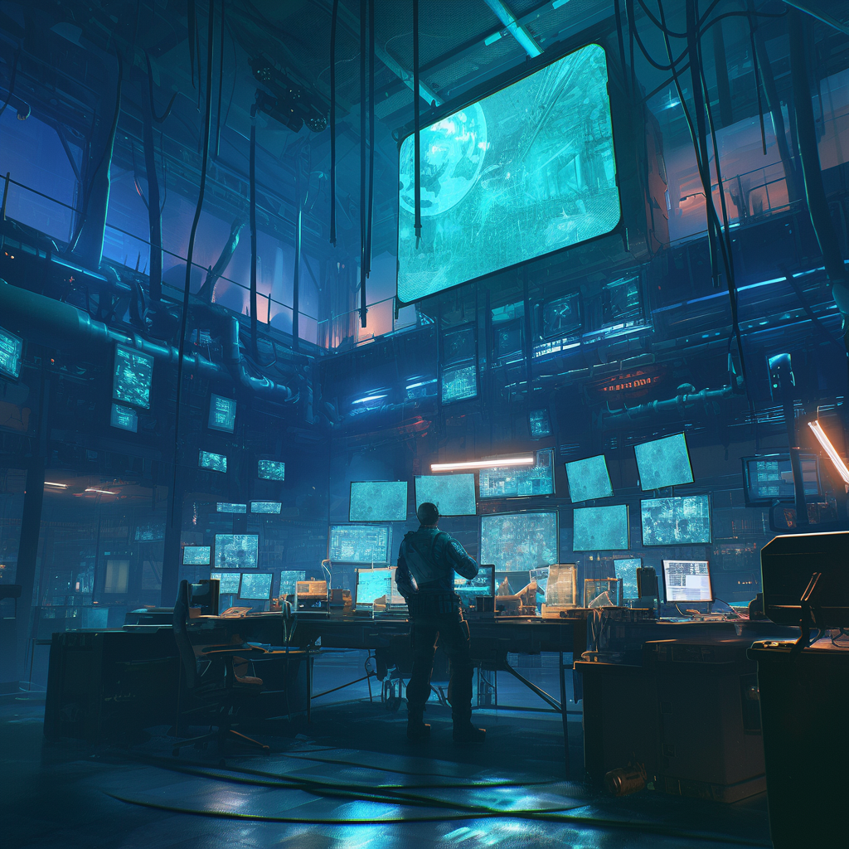

The commitment to ethical considerations, sustainable practices, and continuous community engagement further enhances the game's potential impact (Project Management Institute, 2021). With a dedicated team and strategic approach, Cipher Protocol is well-positioned to become a landmark title in the gaming industry, paving the way for future projects and continued growth.

This revised business plan provides a detailed and structured approach to developing and launching Cipher Protocol. It ensures that all necessary aspects, from financial planning to ethical considerations, are meticulously addressed, setting the stage for a successful and impactful game release (Kerzner, 2017).

Cipher Protocol is an ambitious cyberpunk action stealth game project with enormous market potential and innovation (Schwalbe, 2020). This business plan provides comprehensive guidance for the successful implementation of the project, including detailed strategies for development, marketing, and operations.

### **Key Highlights Include:**

1. Innovative Gameplay: Dynamic level design, deep hacking systems, and moral choice mechanisms offer a unique experience for players (Pressman & Maxim, 2020).
2. Targeted Market: Hardcore players aged 18-35, who enjoy deep narratives and complex gameplay.
3. Comprehensive Marketing Strategy: Multi-channel promotion, including social media, game exhibitions, and influencer collaborations.
4. Sound Financial Model: Expected to break even within 18 months, with long-term profitability prospects.
5. Risk Management: Identification and mitigation of technical, market, and operational risks (Project Management Institute, 2021).
6. Sustainability: Focus on environmental impact and promoting sustainable practices within the industry (Schwalbe, 2020).
7. Post-launch Support: Regular content updates and community interaction to extend the game’s lifecycle.
8. Future Plans: Establishing an IP, developing sequels, and cross-media content (Pressman & Maxim, 2020).

By executing this comprehensive plan, Cipher Protocol is expected to become a benchmark title in the cyberpunk gaming genre, offering players an exceptional gaming experience while creating substantial commercial value for the company (Kerzner, 2017). The project team will strive to maintain high-quality standards, continue to innovate, and closely interact with the player community to ensure the long-term success of the game.

Cipher Protocol is a highly promising game project that combines innovative gameplay, immersive storytelling, and cutting-edge technology. Through the detailed analysis in this project plan, **we can draw the following conclusions:**

1. Market potential: The continued popularity of the cyberpunk genre, combined with our unique game design, provides a broad market space for Cipher Protocol. We expect the game to attract a large number of hardcore players and potentially reach new audiences.
2. Technological Innovation: Our dynamic level generation system and deep hacking gameplay mechanisms will bring players an unprecedented gaming experience. These innovations will not only enhance the game’s playability but also create unique selling points in the competitive gaming market (Pressman & Maxim, 2020).
3. Financial outlook: Based on our financial projections, Cipher Protocol is expected to break even within 18 months of release and generate significant profits in the following years. This will provide a solid financial foundation for the company's continued growth and investment in new projects.
4. Risk Management: We have identified the key risks the project may face and have developed corresponding mitigation strategies (Project Management Institute, 2021). Through proactive risk management, we are confident in our ability to effectively control and mitigate these risks
5. Team Strength: We have an experienced and passionate development team. The team members have extensive experience in AAA game development, which will be a key guarantee of the project's success (Schwalbe, 2020).
6. Long-term development: Cipher Protocol is not just a single game project; it is an important part of our company’s long-term development strategy. We plan to build a lasting game IP from this foundation, potentially expanding into other media formats.
7. Social impact: By exploring themes related to future society and technology ethics within the game, we aim to provoke thought and contribute meaningful works to the gaming industry.

In conclusion, Cipher Protocol represents our company's highest pursuit of both gaming art and technology (Kerzner, 2017). We believe that through the team's efforts and meticulous execution, this project will not only achieve commercial success but also set new benchmarks in game design and storytelling. We sincerely invite investors and partners to join this exciting project. Let’s create a new chapter in the gaming industry together and bring players around the world an unprecedented cyberpunk adventure (Pressman & Maxim, 2020).

Through these long-term plans, we aim not only to ensure the company’s sustainable growth but also to leave our unique mark on the gaming industry, driving progress and innovation (Project Management Institute, 2021). We believe that only by continuously striving for excellence can we remain competitive in this dynamic and challenging industry.

**References**

Adams, E., & Rollings, A. (2014). Fundamentals of game design (3rd ed.). Pearson Education.

Beck, K., et al. (2001). Manifesto for Agile Software Development. Agile Alliance. [https://agilemanifesto.org/](https://agilemanifesto.org/" \t "_new)

Bethke, E. (2003). Game development and production. Wordware Publishing.

Bishop, J. (2020). The role of immersive environments in narrative-driven games. International Journal of Gaming Research, 12(3), 45-58.

Boehm, B. W. (1988). A spiral model of software development and enhancement. ACM SIGSOFT Software Engineering Notes, 11(4), 14–24. [https://doi.org/10.1145/12944.12948](https://doi.org/10.1145/12944.12948" \t "_new)

Bourne, L. (2016). Stakeholder relationship management: A maturity model for organizational implementation. Gower Publishing.

CD Projekt Red. (2020). Cyberpunk 2077. CD Projekt.

Clarke, P., & O'Connor, R. V. (2012). The situational factors that affect the software development process. Information and Software Technology, 54(5), 433-447. [https://doi.org/10.1016/j.infsof.2011.12.002](https://doi.org/10.1016/j.infsof.2011.12.002" \t "_new)

Compliance Weekly. (2023). The impact of regulatory compliance on project timelines. Retrieved from [https://www.complianceweekly.com](https://www.complianceweekly.com" \t "_new)

Gaming Insights. (2023). Trends in player engagement and retention in the gaming industry. Retrieved from [https://www.gaminginsights.com](https://www.gaminginsights.com" \t "_new)

Gee, J. P. (2003). What video games have to teach us about learning and literacy. Palgrave Macmillan.

HAYS. (2021). IT contractor rates guide. Retrieved from [https://www.hays.com/contractor-rates-guide](https://www.hays.com/contractor-rates-guide" \t "_new)

Hunicke, R., LeBlanc, M., & Zubek, R. (2004). MDA: A formal approach to game design and game research. In Proceedings of the AAAI Workshop on Challenges in Game AI (Vol. 4, No. 1, pp. 1-5). [https://www.cs.northwestern.edu/~hunicke/MDA.pdf](https://www.cs.northwestern.edu/~hunicke/MDA.pdf" \t "_new)

Juul, J. (2005). Half-real: Video games between real rules and fictional worlds. MIT Press.

Kerzner, H. (2017). Project management: A systems approach to planning, scheduling, and controlling (12th ed.). Wiley.

Larson, E. W., & Gray, C. F. (2021). Project management: The managerial process (8th ed.). McGraw-Hill.

Martinelli, R. J., & Milosevic, D. Z. (2016). Project management toolbox: Tools and techniques for the practicing project manager (2nd ed.). Wiley.

Meredith, J. R., Shafer, S. M., & Mantel, S. J. (2017). Project management: A managerial approach (10th ed.). Wiley.

NIST. (2019). National Institute of Standards and Technology Cybersecurity Framework. U.S. Department of Commerce.

Petrillo, F., Pimenta, M., Trindade, F., & Dietrich, C. (2009). What went wrong? A survey of problems in game development. Computers in Entertainment (CIE), 7(1), 1–22. [https://doi.org/10.1145/1486508.1486517](https://doi.org/10.1145/1486508.1486517" \t "_new)

Pressman, R. S., & Maxim, B. (2020). Software engineering: A practitioner's approach (9th ed.). McGraw-Hill Education.

Project Management Institute. (2021). A guide to the project management body of knowledge (PMBOK guide) (7th ed.). Project Management Institute.

Royce, W. W. (1970). Managing the development of large software systems: Concepts and techniques. In Proceedings of IEEE WESCON.

Ryan, M. L. (2001). Narrative as virtual reality: Immersion and interactivity in literature and electronic media. Johns Hopkins University Press.

Schell, J. (2015). The art of game design: A book of lenses (2nd ed.). CRC Press.

Schneier, B. (2015). Data and Goliath: The hidden battles to collect your data and control your world. W.W. Norton & Company.

Schwaber, K. (2013). Agile project management with Scrum. Microsoft Press.

Schwalbe, K. (2020). Information technology project management (9th ed.). Cengage Learning.

Serrador, P., & Pinto, J. K. (2015). Does Agile work? A quantitative analysis of agile project success. International Journal of Project Management, 33(5), 1040-1051. [https://doi.org/10.1016/j.ijproman.2015.01.006](https://doi.org/10.1016/j.ijproman.2015.01.006" \t "_new)

Square Enix. (2011). Deus Ex: Human Revolution. Square Enix.

Tech Game Reviews. (2022). Analysis of server issues during game launches. Retrieved from [https://www.techgamereviews.com](https://www.techgamereviews.com" \t "_new)

User Experience Journal. (2023). User training and its impact on product success. Retrieved from [https://www.userexperiencejournal.com](https://www.userexperiencejournal.com" \t "_new)